Task 1: AWS Networking Infrastructure

1. VPC
I created a custom VPC named Dev task 1 with the IPv4 CIDR block 10.0.0.0/16. This gives a private network of 65,536 IP addresses, which I divided into subnets for the three tiers of the application.
Screenshot 1: Custom VPC Dev task 1 with CIDR block 10.0.0.0/16

2. Subnets
I created 6 subnets across two Availability Zones (ap-south-1a and ap-south-1b), so the application can keep running if one zone fails. Each subnet uses a /24 CIDR block, which gives 256 IP addresses.
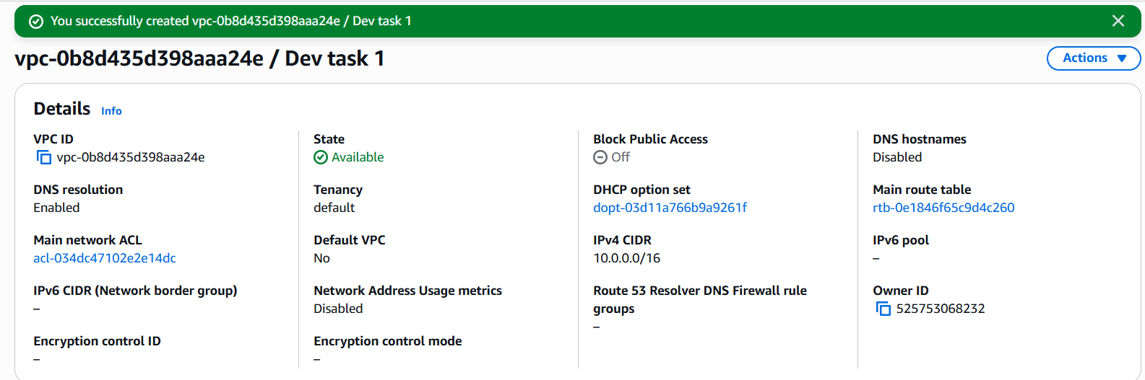
Then I Enable auto-assign public IPv4 address for both public web-1 & web-2.
Subnet name | Availability Zone | IPv4 CIDR
public-web-1 | ap-south-1a | 10.0.1.0/24
public-web-2 | ap-south-1b | 10.0.2.0/24
private-app-1 | ap-south-1a | 10.0.3.0/24
private-app-2 | ap-south-1b | 10.0.4.0/24
private-db-1 | ap-south-1a | 10.0.5.0/24
private-db-2 | ap-south-1b | 10.0.6.0/24
Screenshot 2: Six subnets across two Availability Zones.
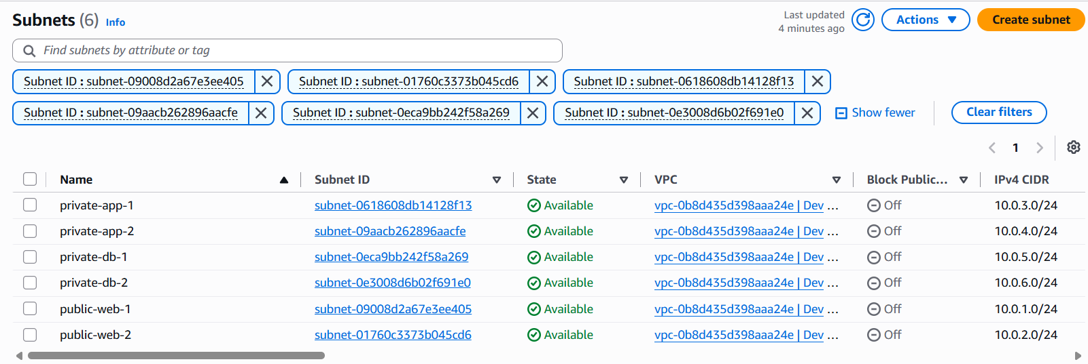

3. Internet Gateway
I created an Internet Gateway named Dev Gateway and attached it to the VPC. It allows resources in the public subnets to communicate with the internet.
Screenshot 3: Internet Gateway attached to the VPC.
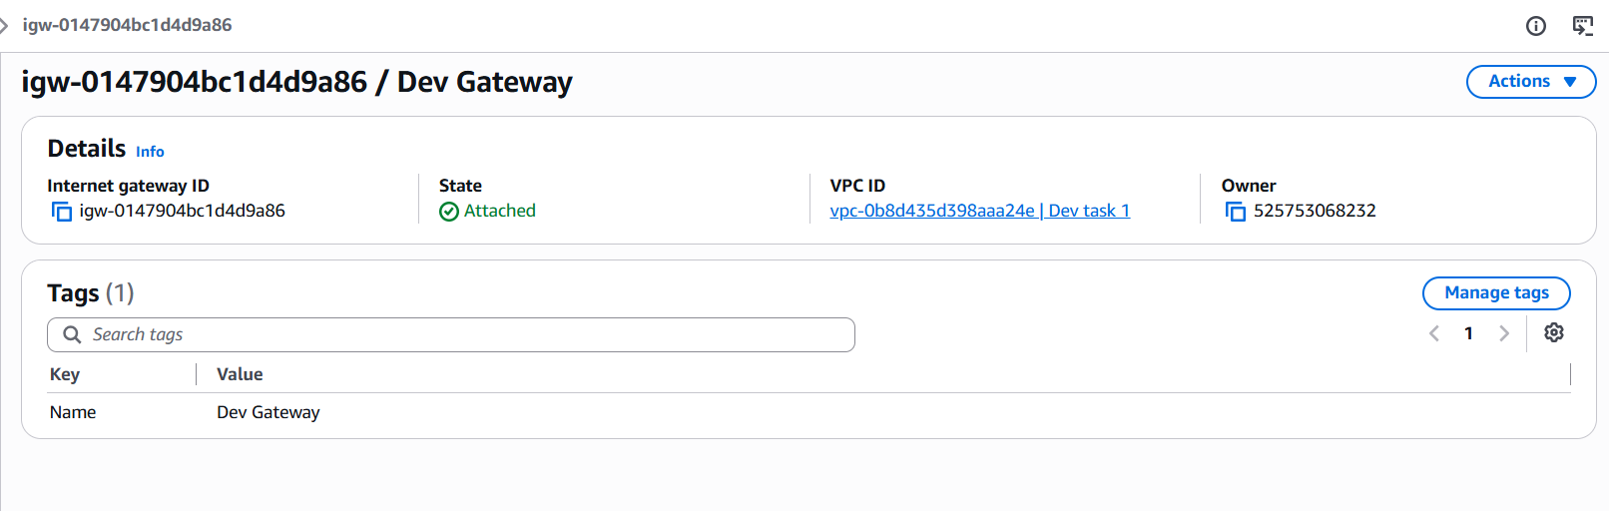

4. Elastic IP and NAT Gateway
I allocated an Elastic IP and created a NAT Gateway named Dev Nat gateway in the public subnet public-web-1, using that Elastic IP. The NAT Gateway lets the private application servers reach the internet, while keeping them unreachable from the internet.
The Elastic IP 65.0.164.124 was allocated to my account and associated with the NAT Gateway. It gives the NAT Gateway a fixed public address for outbound internet traffic.
Screenshot 4: Elastic IP allocated for the NAT Gateway
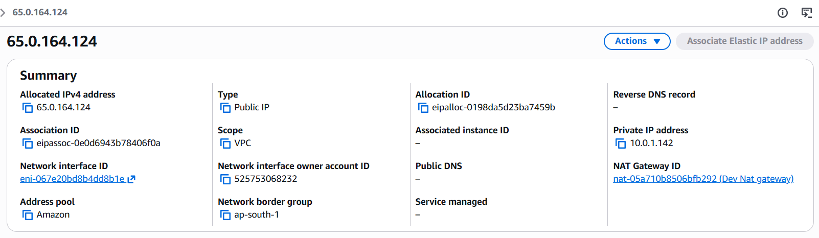

5. Route tables
I created three route tables and associated them with the subnets:
- Public route table (public-rt): sends 0.0.0.0/0 traffic to the Internet Gateway (Dev Gateway). It is associated with public-web-1 and public-web-2, so these subnets are public.
- Private application route table (private-app-rt): sends 0.0.0.0/0 traffic to the NAT Gateway (Dev Nat gateway). It is associated with private-app-1 and private-app-2.
- Private database route table (private-db-rt): has only the local route, so the database tier has no route to the internet. It is associated with private-db-1 and private-db-2.
Screenshot 5: Public route table with route to the Internet Gateway with subnet associations public-web-1 and public-web-2.
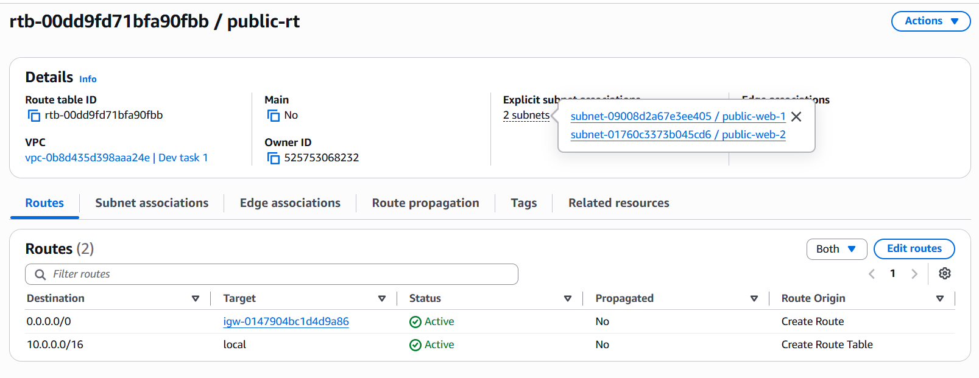
Screenshot 6: Private application route table with route to the NAT Gateway with subnet associations private-app-1 and private-app-2.
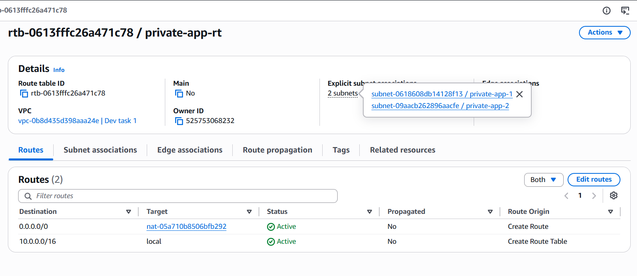
Screenshot 7: It has only the local route, so the database tier has no route to the internet. It is associated with private-db-1 and private-db-2.
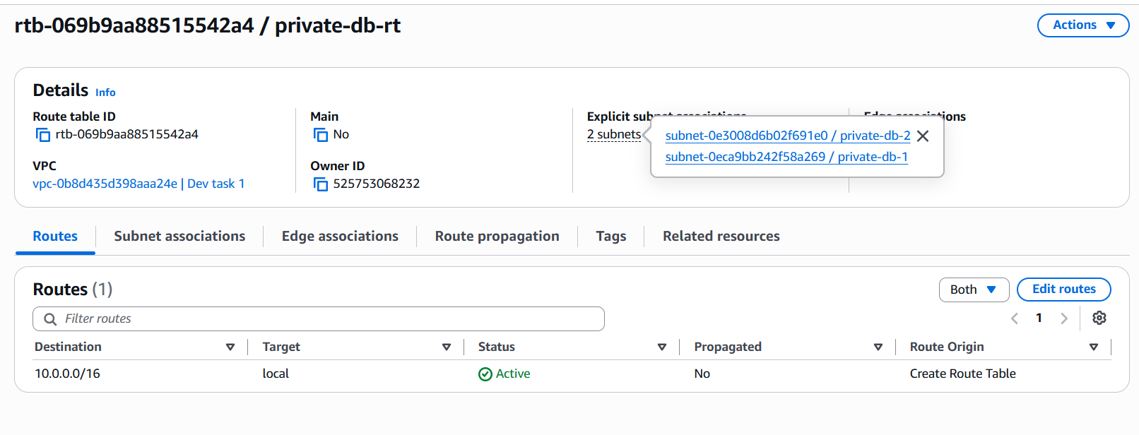

6. Resource map
The VPC resource map shows the complete network: 6 subnets across two Availability Zones, the three route tables I created, the Internet Gateway (Dev Gateway) for the public subnets and the NAT Gateway (Dev Nat gateway) for the private application subnets. This network is the base for deploying the web, application and database tiers.
Screenshot 8: VPC resource map showing the complete network.
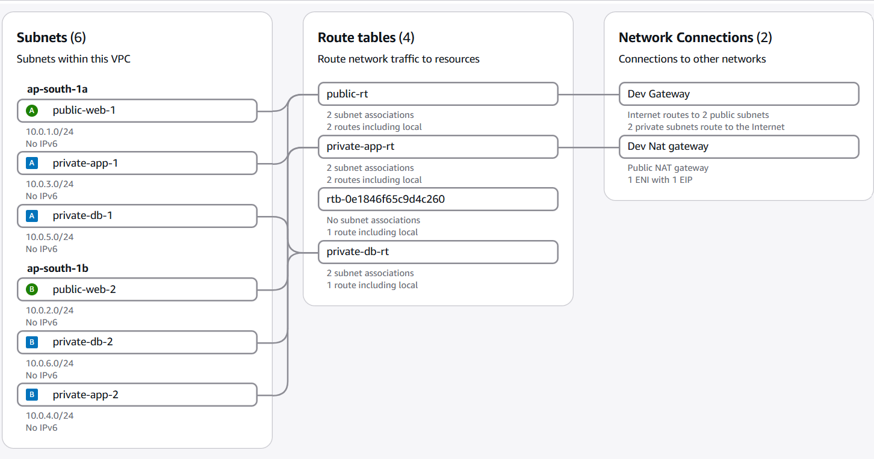

7. Outbound connectivity check
To verify that private resources can reach the internet through the NAT Gateway, I launched a temporary EC2 instance in private-app-1 with no public IP and connected through Session Manager. The command curl https://checkip.amazonaws.com returned 65.0.164.124, the Elastic IP of the NAT Gateway. This confirms the traffic leaves through the NAT Gateway.
Screenshot 9: Terminal output from the private instance showing the NAT Gateway’s IP
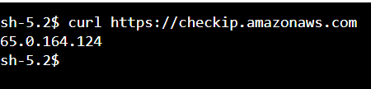

Task 2: Web tier

1. Launching the web server
I launched an EC2 instance named Devops Server using Amazon Linux 2023 and the instance type t3.micro. I placed it in the public subnet public-web-1 of the VPC Dev task 1 and enabled auto-assign public IP, so it is reachable from the internet. It runs in the Availability Zone ap-south-1a.
Screenshot 1: Devops Server running in the public subnet with a public IPv4 address.
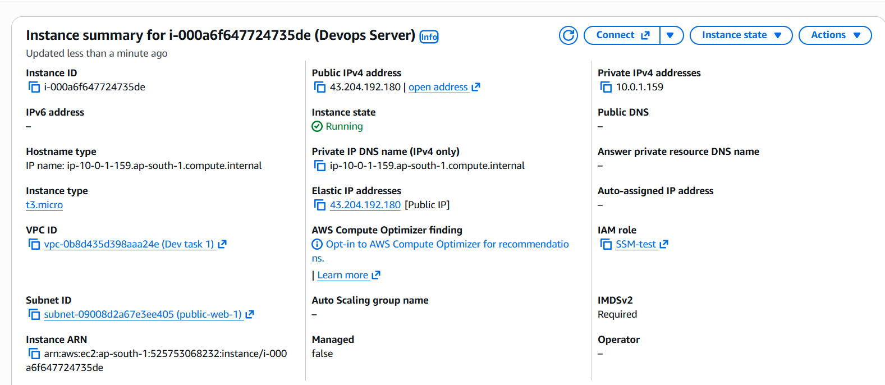

2. Security group
I created a security group named launch-wizard-2 for the web tier. It has one inbound rule that allows HTTP (TCP port 80) from 0.0.0.0/0, so users can open the website. I removed the SSH rule, so port 22 is closed, and I managed the server through AWS Systems Manager Session Manager instead.
Screenshot 2: Inbound rules of Launch-wizard-2.
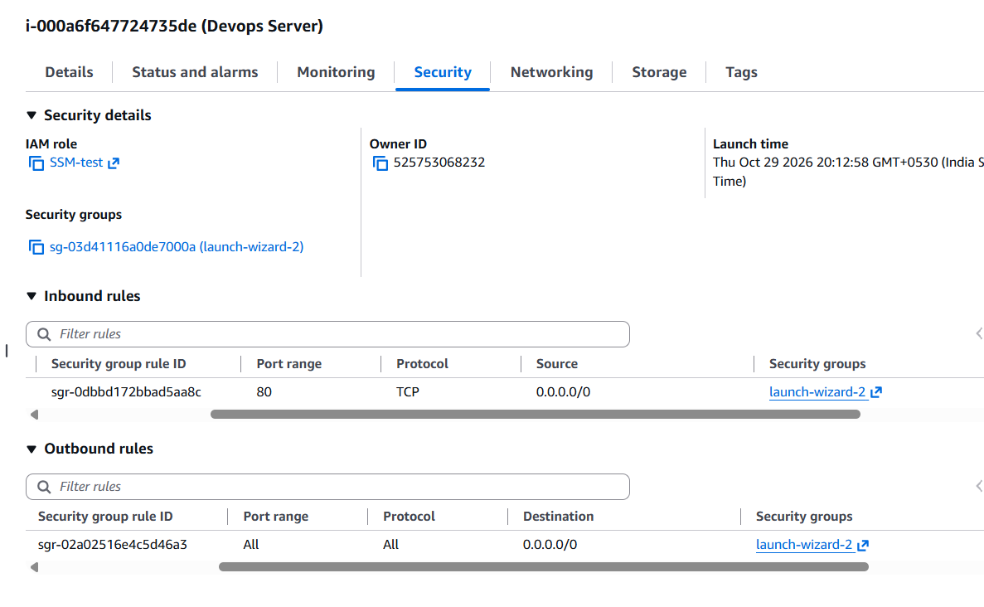

3. Connecting to the instance
I attached the IAM role ssm-test-role (with the AmazonSSMManagedInstanceCore policy) to the instance and connected through Session Manager. This gives secure terminal access without SSH keys or open ports.
Screenshot 3: Session Manager terminal connected to Devops Server (Instance).
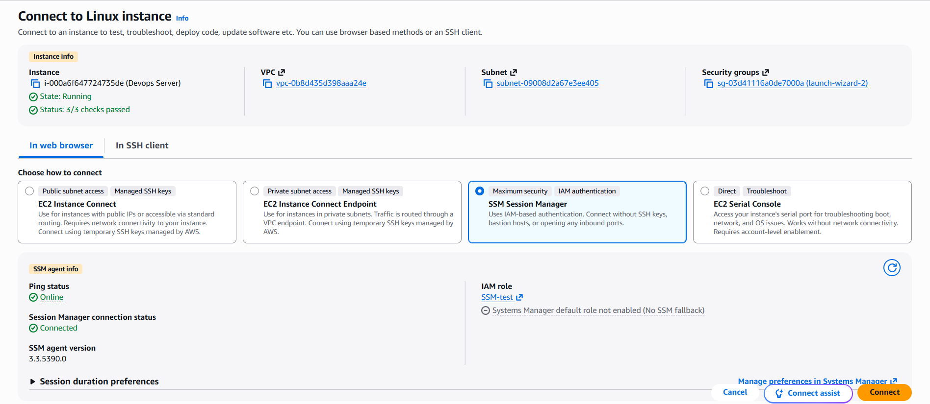

4. Installing and starting Nginx
I installed Nginx with sudo dnf install nginx -y, started it with sudo systemctl start nginx and enabled it at boot with sudo systemctl enable nginx. The service status shows active (running).
Screenshot 4: nginx service status showing active (running).
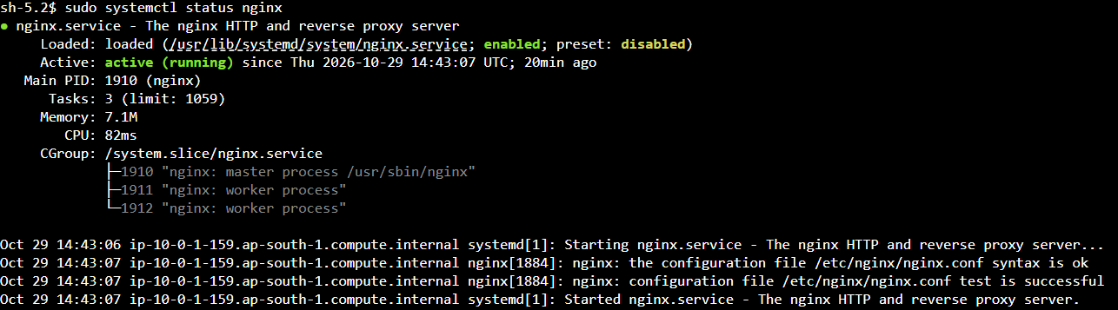

5. Deploying the web page
I created the index.html feedback form in /usr/share/nginx/html/ the default web root of Nginx. The page has fields for name, email and feedback, and a Submit button that sends the data to the /api/submit endpoint.
Screenshot 5: Terminal showing the contents of index.html
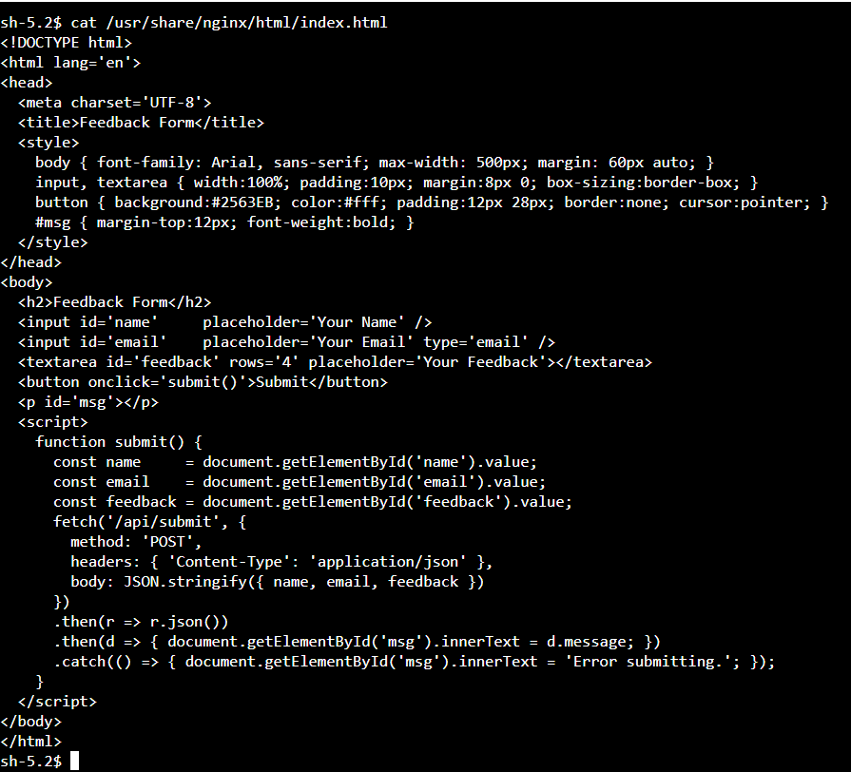

6. Verification
I opened the public IP address of the instance, http://43.204.192.180, in a browser, and the Feedback Form loaded correctly. This confirms that the instance, the security group and Nginx work. The Submit button will work after the application tier and the proxy configuration are completed.
Screenshot 6: Feedback Form loading in the browser through the public IP.
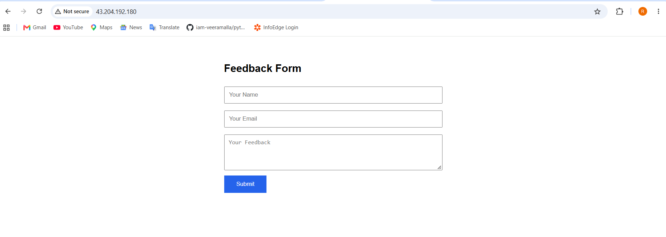

Task 3: Application Tier

1. Launching the application server
I launched an EC2 instance named Backend API server using Ubuntu Server [26.04 LTS] and the instance type [t3.micro]. I placed it in the private application subnet private-app-1 of the VPC Dev task 1 and disabled auto-assign public IP, so the server has no public address and can’t be reached directly from the internet.
Screenshot 1: Backend API server running in the private subnet with no public IPv4 address.
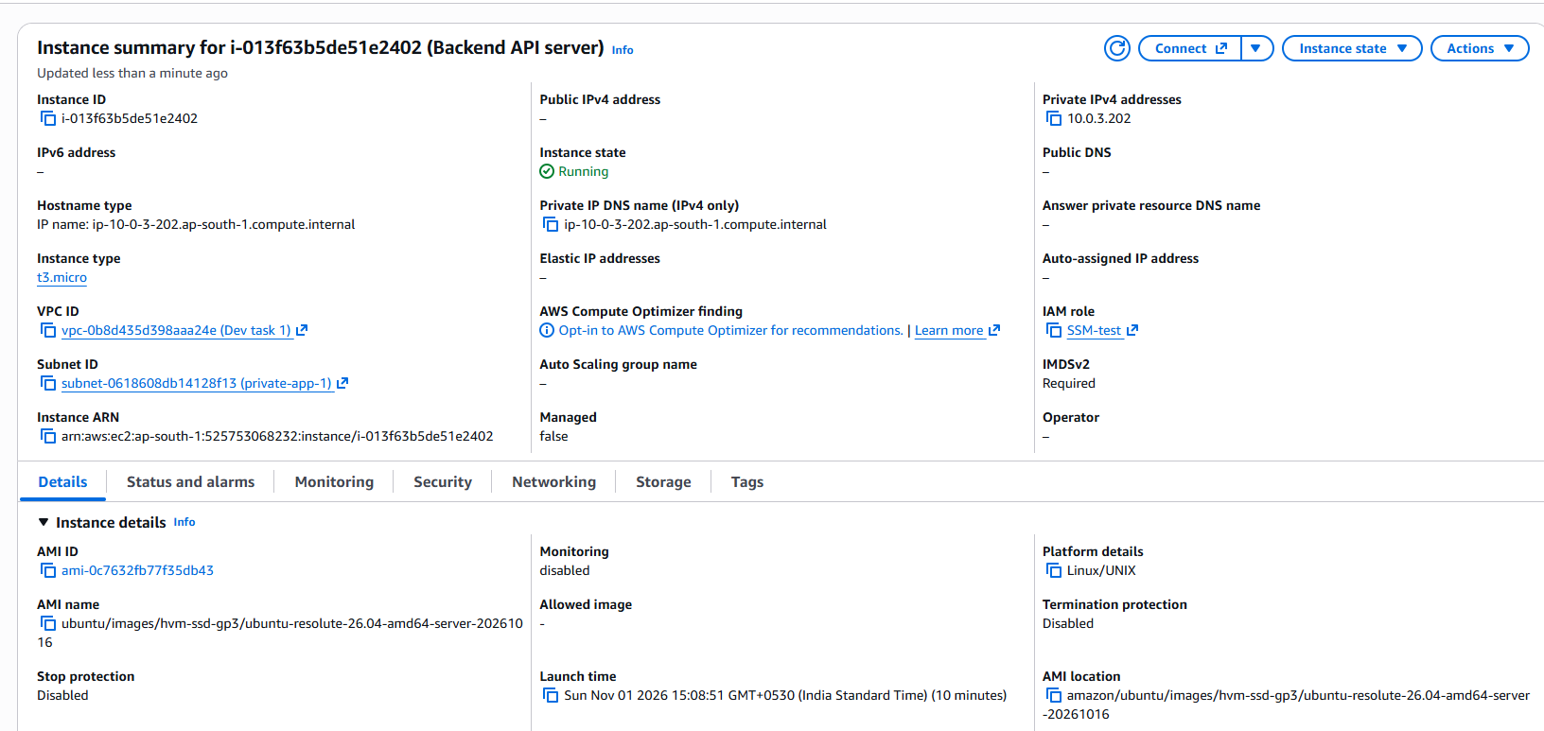

2. Security group
I created a security group named app-sg for the application tier. It has one inbound rule that allows custom TCP on port 5000, the port the Flask application listens on, from the VPC CIDR 10.0.0.0/16. SSH is not allowed. This rule will be restricted to the internal load balancer in the security task.
Screenshot 2: Inbound rules of app-sg.
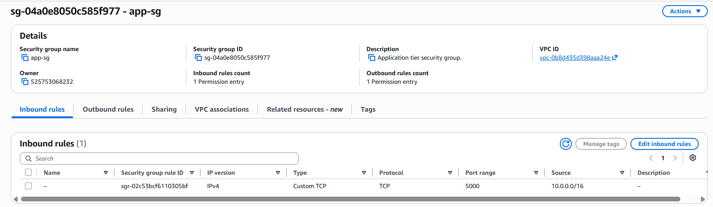

3. Connecting to the instance
I attached the IAM role ssm-test-role (policy AmazonSSMManagedInstanceCore) to the instance and connected through AWS Systems Manager Session Manager. No bastion host, SSH keys or open inbound ports were needed.
Screenshot 3: Session Manager terminal connected to Backend API server.
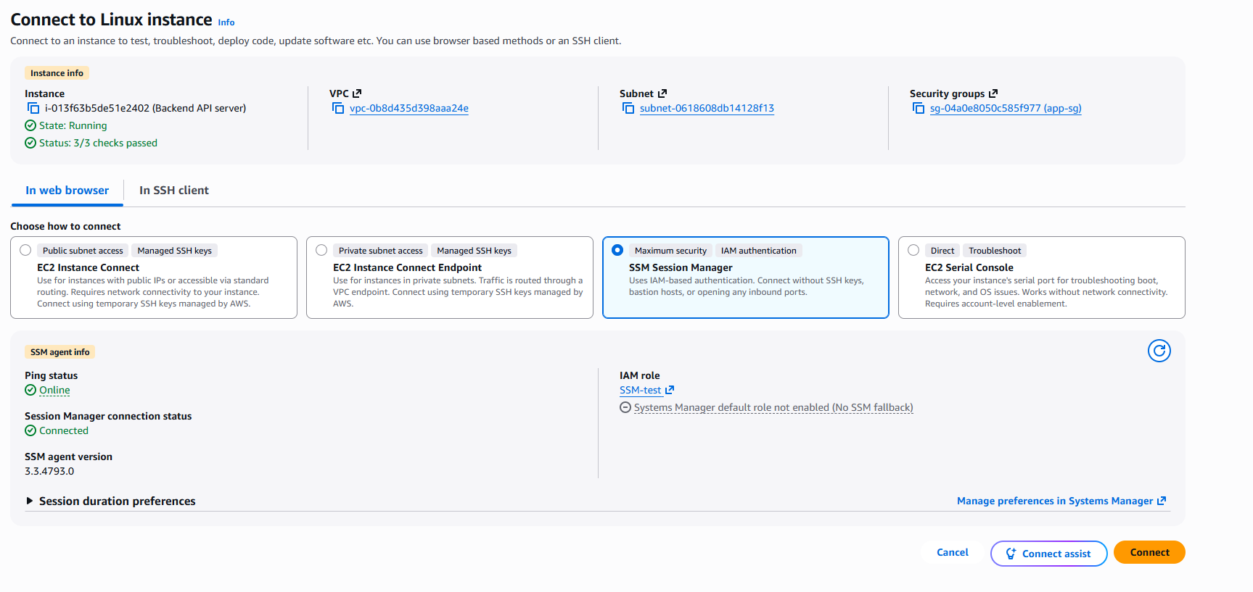

4. Verifying outbound internet access through the NAT Gateway
From the private server I ran curl https://checkip.amazonaws.com, which returned 65.0.164.124, the Elastic IP of the NAT Gateway. This confirms that the private instance reaches the internet through the NAT Gateway, even though it has no public IP of its own.
Screenshot 4: Terminal output showing the NAT Gateway’s public IP.
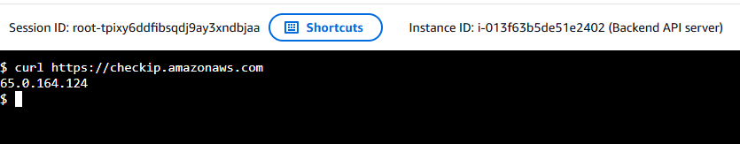

5. Installing Python and the required packages
I updated the system and installed python3-pip, python3-venv and python3-full with apt. I created a Python virtual environment named venv and activated it, then installed the dependencies with pip install Flask PyMySQL gunicorn. I also installed the MySQL client (default-mysql-client), which is used later to connect to the Amazon RDS database.
Screenshot 5: Virtual environment active and pip install completed (“Successfully installed”).
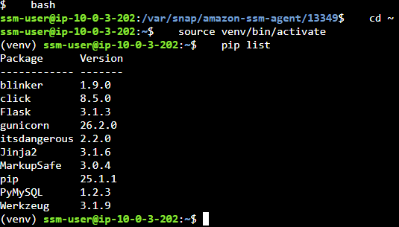

6. Creating the Flask application
I created the app.py file with the Flask application code. It has a health route / that returns a JSON status message and a /submit route that accepts POST requests and stores the feedback in the database. The application runs on host 0.0.0.0 and port 5000, so it accepts connections from the load balancer.

7. Running the application and verification
I started the application and tested it with curl localhost:5000, which returned {"status":"Flask is running"}. This confirms the application is running on port 5000.
Screenshot 6: curl localhost:5000 output.
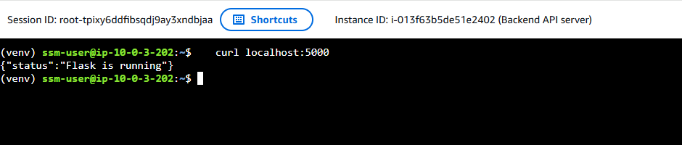

8. Running Flask as a service
To keep the application running after a restart or when the terminal session closes, I created a systemd service named flask-app that starts app.py with the virtual environment’s Python, restarts it automatically if it stops, and starts at boot. The service status shows active (running).
Screenshot 7: Output of sudo systemctl status flask-app showing active (running).
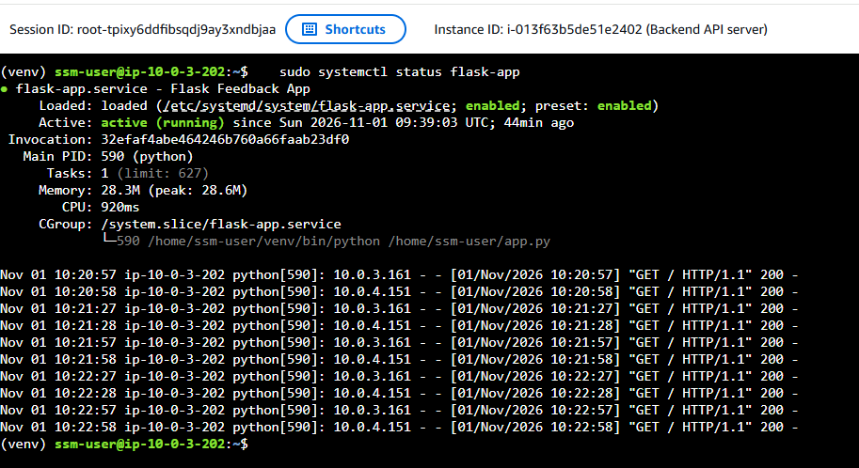

9. Second application server
To spread the application tier across both Availability Zones, I created an image (AMI) of Backend API server and launched Backend AMI from it in the private subnet private-app-2 (ap-south-1b), with no public IP, the same security group app-sg and the same IAM role. The Flask service started automatically, and curl localhost:5000 returned the same status message.
Screenshot 8: curl localhost:5000 output from Backend AMI.
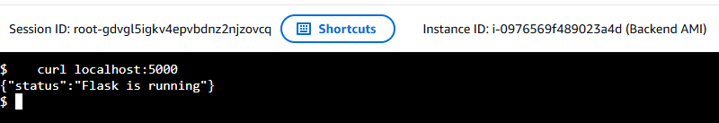

Task 4: Database Tier

1. Database security group
I created a security group named Database Tier-SG for the database tier. It has one inbound rule that allows MySQL/Aurora (TCP port 3306) only from the application tier security group app-sg. No IP range is allowed, so only the application servers can reach the database.
Screenshot 1: Inbound rules of db-sg.
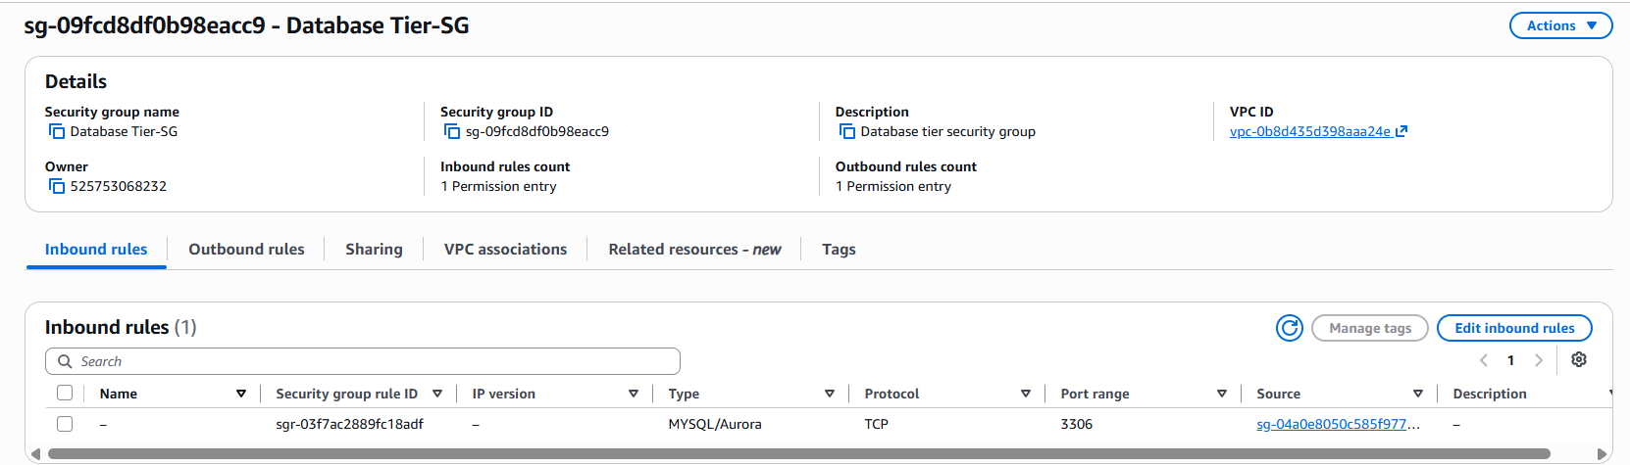

2. DB subnet group
I created a DB subnet group named db-subnet-group in the VPC Dev task 1. It contains the two private database subnets, private-db-1 (10.0.5.0/24, ap-south-1a) and private-db-2 (10.0.6.0/24, ap-south-1b), so RDS places the database in the database tier only.
Screenshot 2: DB subnet group showing both database subnets.
- Private-db-1:
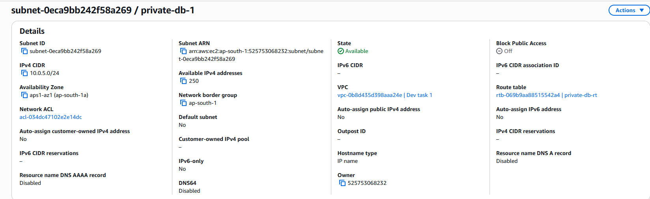
- Private-db-2:
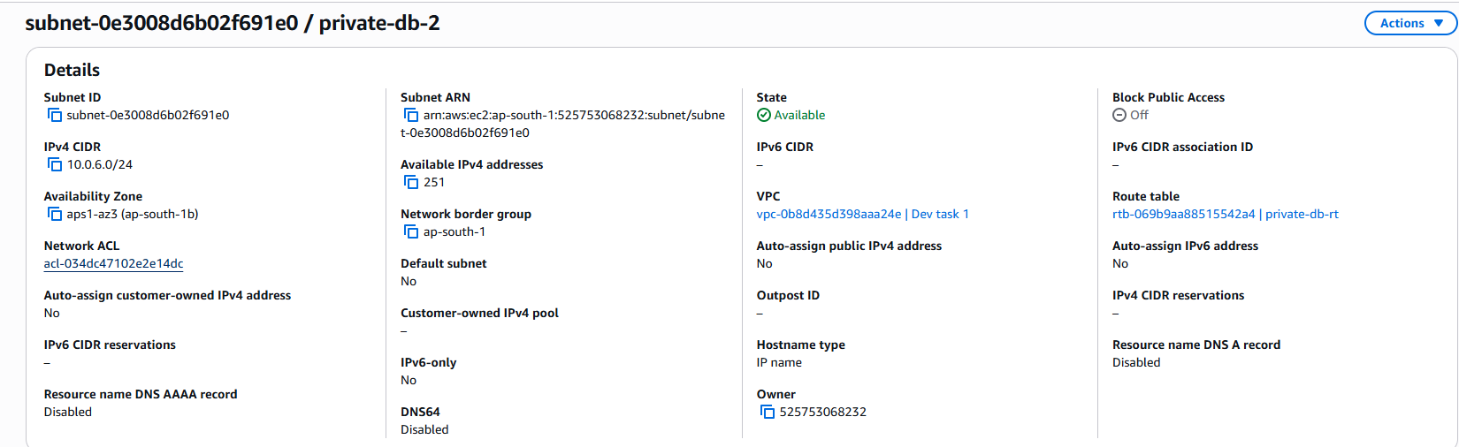

3. Creating the RDS MySQL instance
I created an Amazon RDS for MySQL instance named feedback-db (engine version MySQL 8.4) with the instance class [db.t3.micro] in a single Availability Zone. As per given master username to admin with a password is used. In the connectivity settings I selected the VPC Dev task 1, the DB subnet group db-subnet-group and the security group db-sg, and I set Public access to No. Storage encryption is enabled with the default AWS-managed key. Automated backups and deletion protection are turned off for this project environment.
Screenshot 3: RDS database list showing feedback-db with status Available.
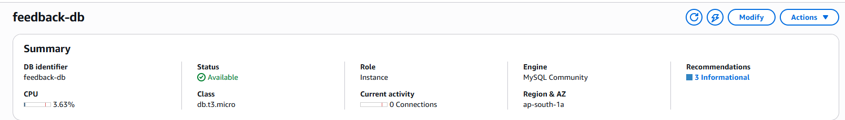
Screenshot 4: Connectivity and security tab (endpoint, VPC, subnet group, security group, public access: No)
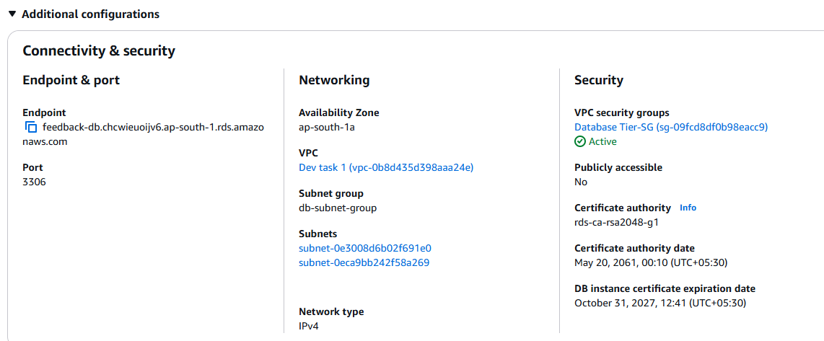

4. Connecting to the database from the application server
Because the database is private, I connected to it from the application server app-server-1 (through Session Manager) using the MySQL client with the RDS endpoint:
mysql -h feedback-db.chcwieuoijv6.ap-south-1.rds.amazonaws.com -u admin -p
The connection succeeded, which confirms that the application tier can reach the database tier through db-sg.
Screenshot 5: Successful connection to the MySQL server from the Backend API server.
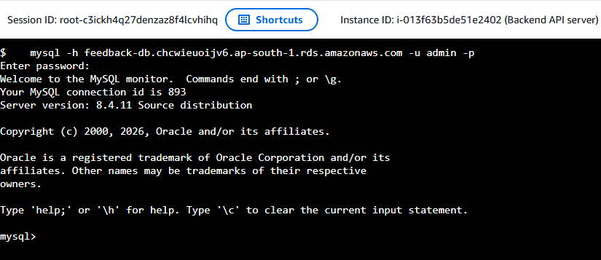

5. Creating the database and table
I ran the provided SQL commands to create the application database feedbackdb and the feedback table, which stores each submission:
- id: an auto-incrementing primary key
- name: Demo
- email: demo@example.com
- feedback: Testing
- created: a timestamp set automatically when the row is inserted
I verified the result with SHOW TABLES; and DESCRIBE feedback;
Screenshot 6: Output of SHOW TABLES; and DESCRIBE feedback;
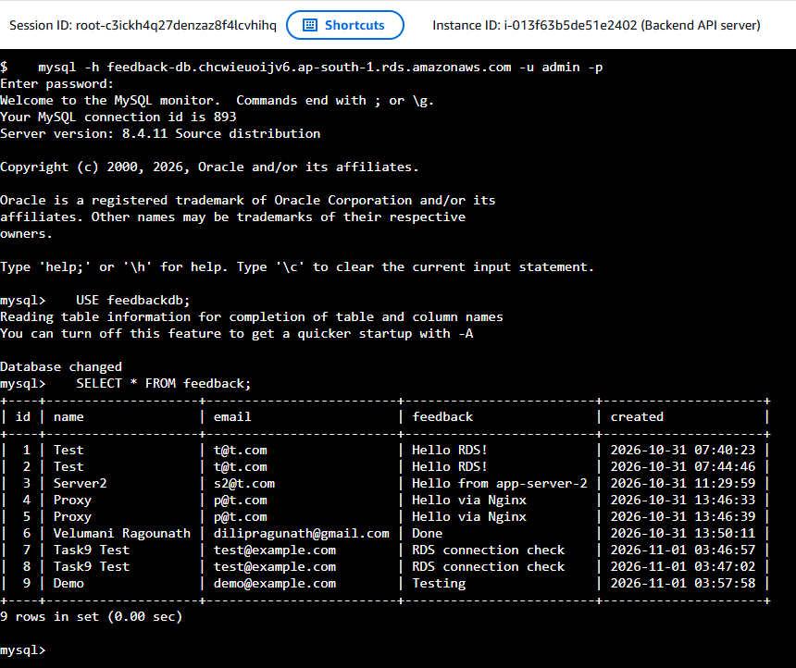

6. Verifying connectivity from the Flask application
I replaced the RDS-ENDPOINT placeholder in app.py with the real RDS endpoint and restarted the flask-app service. I then sent a test request to the API on the application server:
curl -X POST http://localhost:5000/submit -H "Content-Type: application/json" -d '{"name":"Test","email":"t@t.com","feedback":"Hello RDS!"}'
The API returned {"message":"Feedback submitted successfully!"}. I reconnected to the database and ran SELECT * FROM feedback;, and the test record appeared in the table. This confirms that the Flask application stores data in Amazon RDS.
Screenshot 7: curl request and its success response.
Screenshot 8: Output of SELECT * FROM feedback; showing the stored record
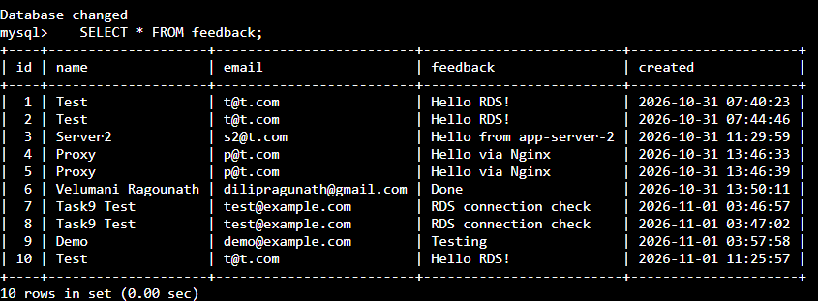

7. Second application server
I made the same endpoint change in app.py on Backend AMI and restarted its flask-app service, so both application servers use the same RDS database.

Task 5: Implement of Network and Instance Security

Overview
I secured the architecture with five security groups, one for each layer. Each group allows inbound traffic only from the layer in front of it, and only on the port that layer needs. Security group references are used instead of IP ranges between the tiers, so access doesn’t depend on addresses. Only the public load balancer accepts traffic from the internet. SSH is not open on any server, and I managed the instances through AWS Systems Manager Session Manager.
Security group | Protects | Allowed inbound traffic | Source
public-alb-sg | Public load balancer | HTTP, TCP 80 | Internet (0.0.0.0/0)
launch-wizard-2 | Web servers (Nginx) | HTTP, TCP 80 | public-alb-sg
internal-alb-sg | Internal load balancer | HTTP, TCP 80 | launch-wizard-2
app-sg | Application servers (Flask) | Custom TCP 5000 | internal-alb-sg
Database Tier-SG | Amazon RDS MySQL | MySQL/Aurora, TCP 3306 | app-sg

1. Load balancer security groups
I created public-alb-sg for the internet-facing load balancer. It allows HTTP on port 80 from anywhere, since this is the public entry point of the application. I created internal-alb-sg for the internal load balancer. It allows HTTP on port 80 only from the web tier security group web-sg, so only the web servers can send requests to the application tier.
Screenshot 1: Inbound rules of public-alb-sg.
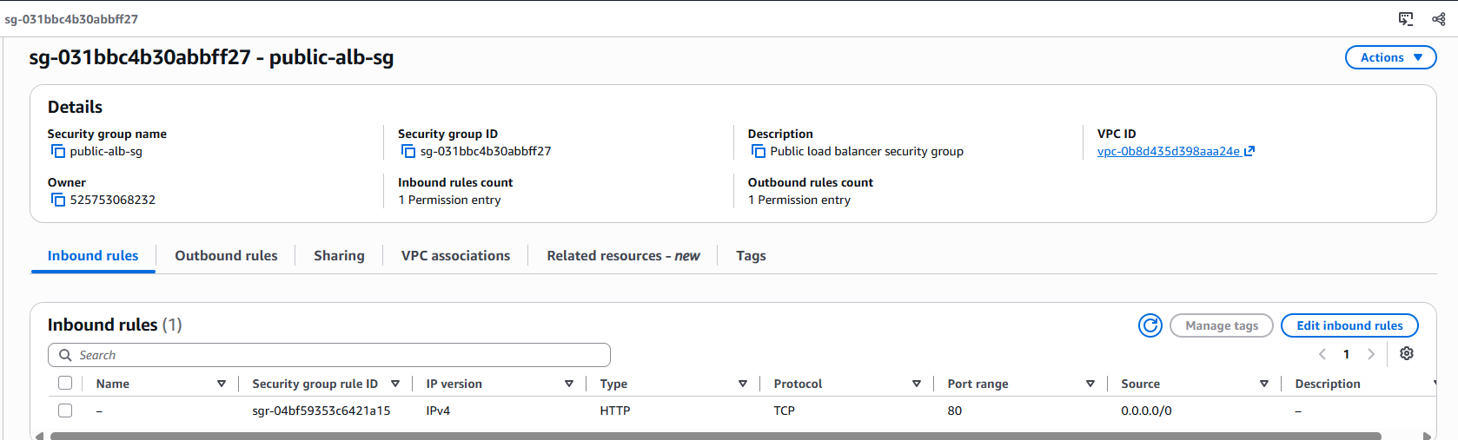
Screenshot 2: Inbound rules of internal-alb-sg.
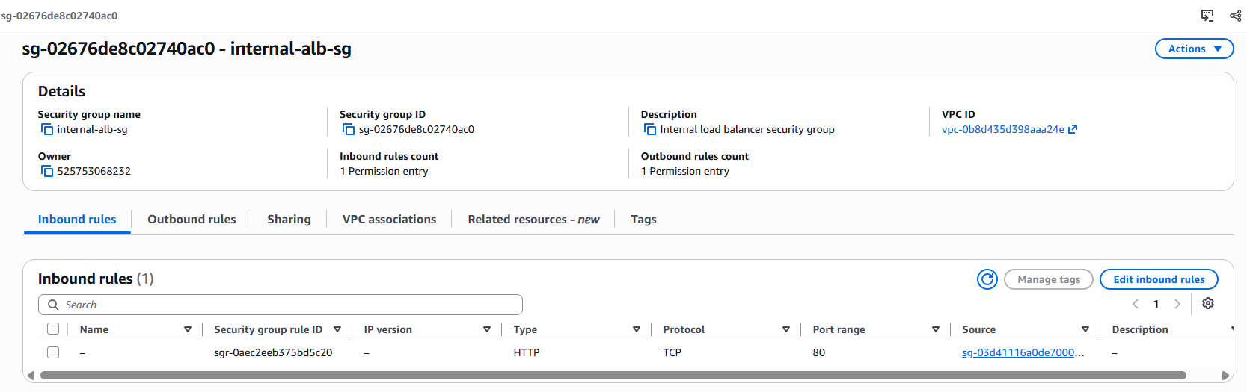

2. Web tier security group
The web security group launch-wizard-2 allows HTTP on port 80 only from public-alb-sg. I removed the temporary rule that allowed HTTP from 0.0.0.0/0, which I had used only for testing the web servers directly, so users can reach the web servers only through the public load balancer. There is no SSH rule.
Screenshot 3: Inbound rules of launch-wizard-2.
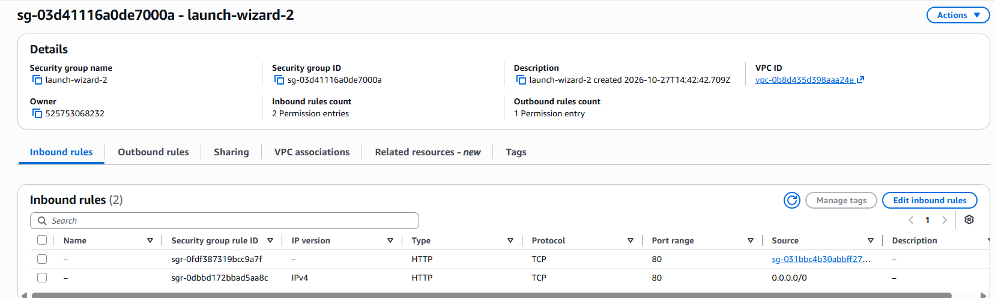

3. Application tier security group
The application security group app-sg allows custom TCP port 5000, the port Flask listens on, only from internal-alb-sg. I removed the temporary rule that allowed port 5000 from the VPC CIDR 10.0.0.0/16. The application servers are in private subnets with no public IP addresses, and only the internal load balancer can reach them.
Screenshot 4: Inbound rules of app-sg.
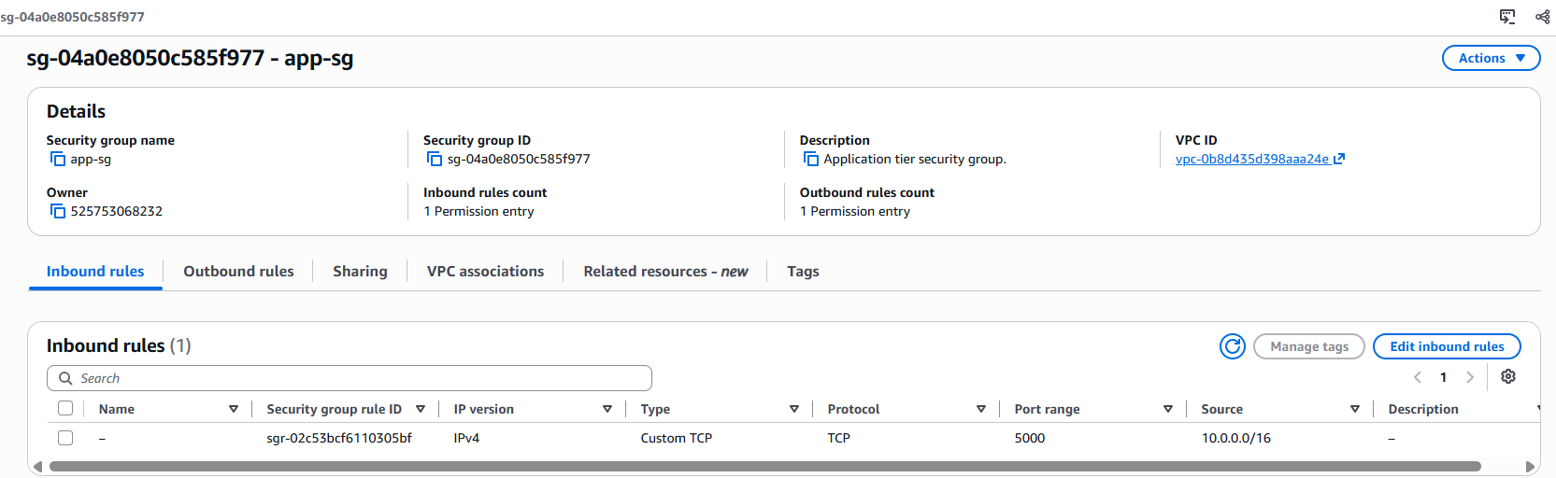

4. Database tier security group
The database security group Database Tier-SG allows MySQL/Aurora on port 3306 only from app-sg. The RDS instance is in the private database subnets with public access disabled, so only the application servers can connect to it.
Screenshot 5: Inbound rules of Database Tier-SG.
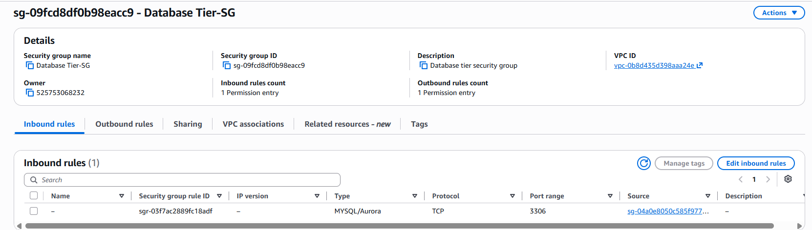

5. Resulting traffic flow
Together, the rules enforce this path and block every other one:
Internet → public-alb-sg (80) → web-sg (80) → internal-alb-sg (80) → app-sg (5000) → db-sg (3306).
For example, the internet cannot reach the application servers or the database directly, and the web servers cannot connect to the database. I left the outbound rules at their default (all traffic), because the inbound rules control which connections are allowed, and the servers need outbound access for updates and packages.

Task 6: Internet-Facing Application Load Balancer

1. Creating the target group
I created a target group named web-tg with the target type Instances, protocol HTTP and port 80, the port Nginx listens on, in the VPC Dev task 1. For the health check I used the protocol HTTP and the path /, so a web server counts as healthy when it serves the Feedback Form page successfully.

2. Registering the web instances
I registered the two web servers as targets on port 80: [Devops Server] in the public subnet public-web-1 (ap-south-1a) and [server 2] in the public subnet public-web-2 (ap-south-1b). Because the servers are in two Availability Zones, the load balancer keeps the website available if one zone fails.
Screenshot 1: Target group details and health check configuration & Registered targets in the target group.
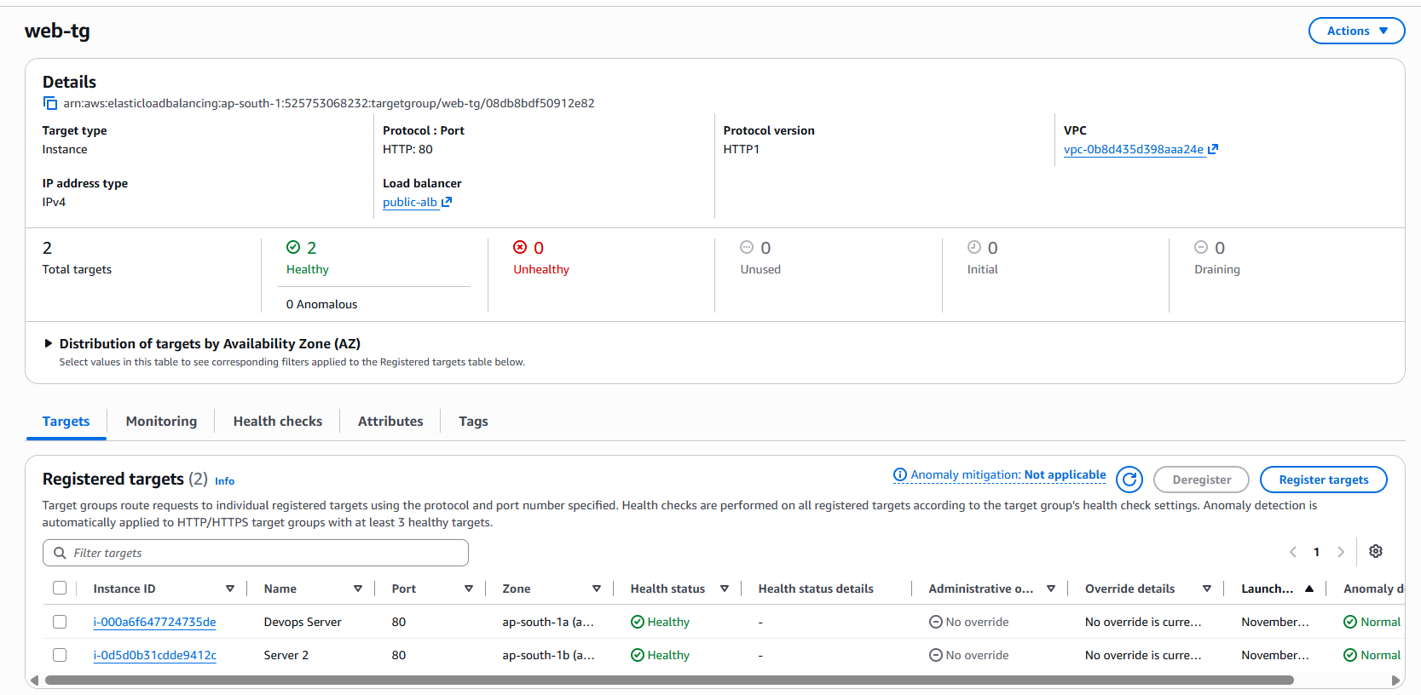

3. Creating the internet-facing load balancer
I created an Application Load Balancer named [public-alb] with the scheme Internet-facing, so it is reachable from the internet. I attached it to the two public subnets, public-web-1 and public-web-2 (one in each Availability Zone), and gave it the security group public-alb-sg, which allows HTTP on port 80 from anywhere (0.0.0.0/0). The listener accepts HTTP on port 80 and forwards requests to the target group web-tg.
Screenshot 2: Load balancer details & Listener configuration showing HTTP:80 forwarding to web-tg.
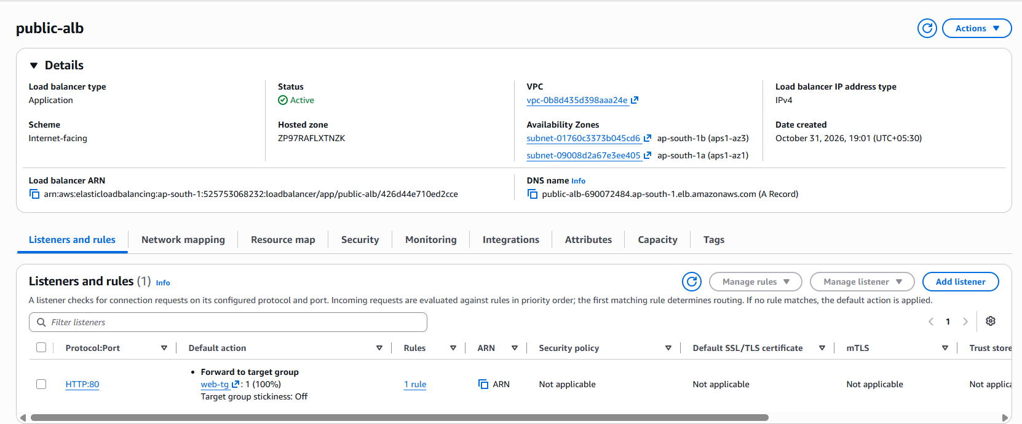

4. Health checks
After the load balancer became Active, both web servers passed the health check and showed the status Healthy. The web security group web-sg allows HTTP on port 80 from public-alb-sg, so the load balancer can reach the servers.
Screenshot 3: Targets tab showing both website servers Healthy
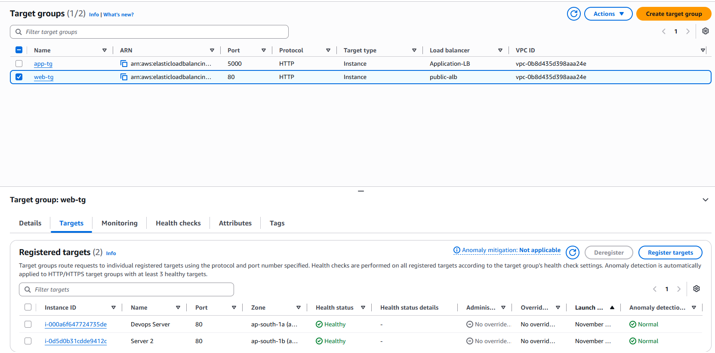

5. Verifying access through the load balancer DNS name
I opened the DNS name of the load balancer, http://public-alb-690072484.ap-south-1.elb.amazonaws.com in a browser, and the Feedback Form loaded. This confirms that traffic from the internet reaches the web servers through the public load balancer.
Screenshot 4: Browser showing the Feedback Form with the ALB DNS name in the address bar.
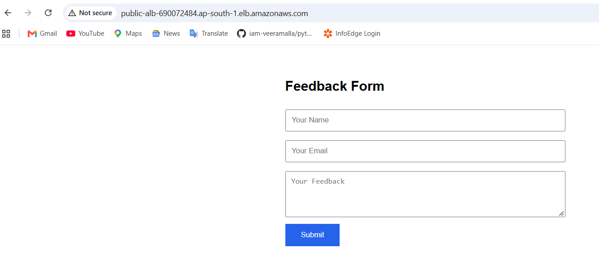

6. Result
The web tier is now accessed through the public load balancer, which spreads requests between the two web servers and checks their health. Users no longer need the individual server IP addresses. The form’s Submit button is connected to the backend in the next tasks, through the Nginx reverse proxy and the internal load balancer.

Task 7: Internal Application Load Balancer

1. Creating the target group
I created a target group named [app-tg] with the target type Instances, protocol HTTP and port 5000, the port the Flask application listens on, in the VPC Dev task 1. For the health check I used the protocol HTTP and the path /, which returns a JSON status message from the Flask application, so a healthy server answers with a success response.

2. Registering the Flask instances
I registered the two application servers, Backend API server (in private-app-1, ap-south-1a) and app-server-2 (in private-app-2, ap-south-1b), as targets on port 5000. Because the servers are in two Availability Zones, the load balancer can keep serving requests if one zone fails.

3. Creating the internal load balancer
I created an Application Load Balancer named [Application-LB] with the scheme Internal, so it has no public address and can’t be reached from the internet. I placed it in the private application subnets private-app-1 and private-app-2 (one in each Availability Zone) and attached the security group internal-alb-sg, which allows HTTP on port 80 only from the web tier security group web-sg. The listener accepts HTTP on port 80 and forwards requests to the target group [app-tg].
Screenshot 1: Load balancer details & Listener configuration showing HTTP:80 forwarding to the target group.
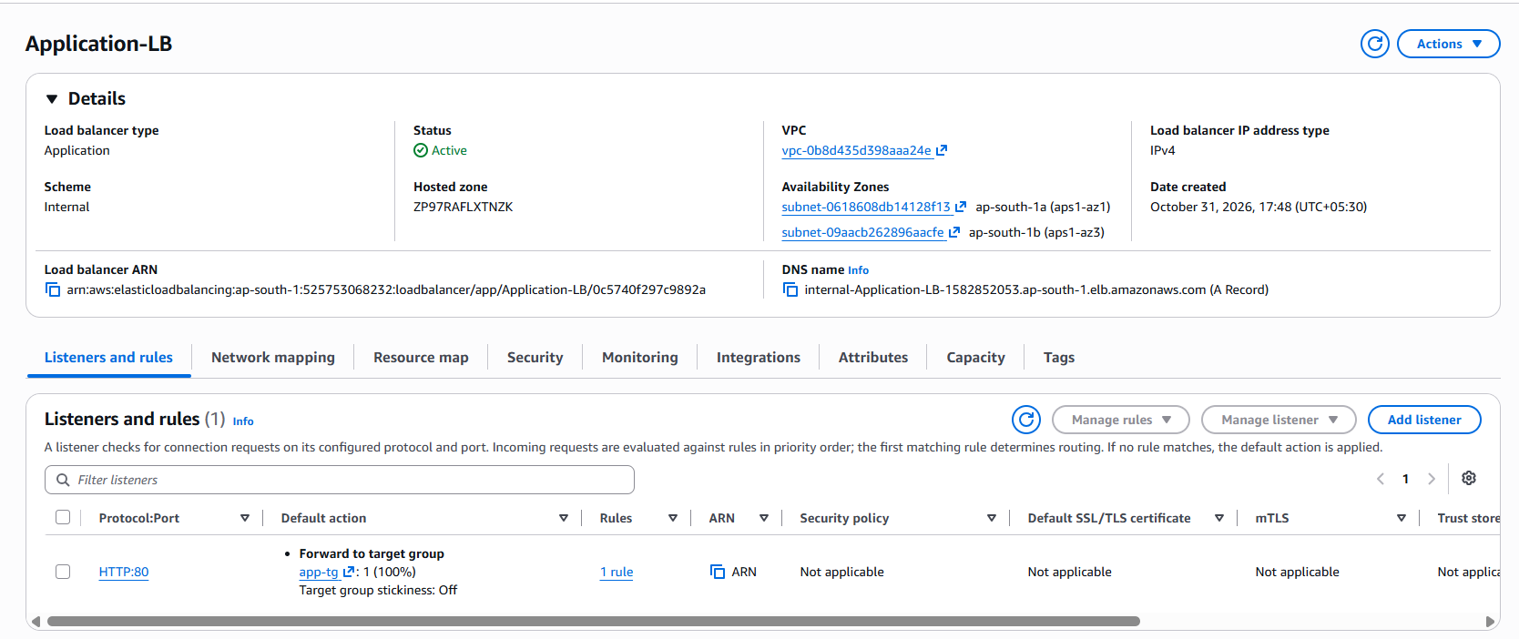

4. Health checks
After the load balancer became Active, both registered targets passed the health check and showed the status Healthy. The application security group app-sg allows port 5000 from internal-alb-sg, so the load balancer can reach the Flask servers.
Screenshot 2: Targets tab showing both application servers Healthy.
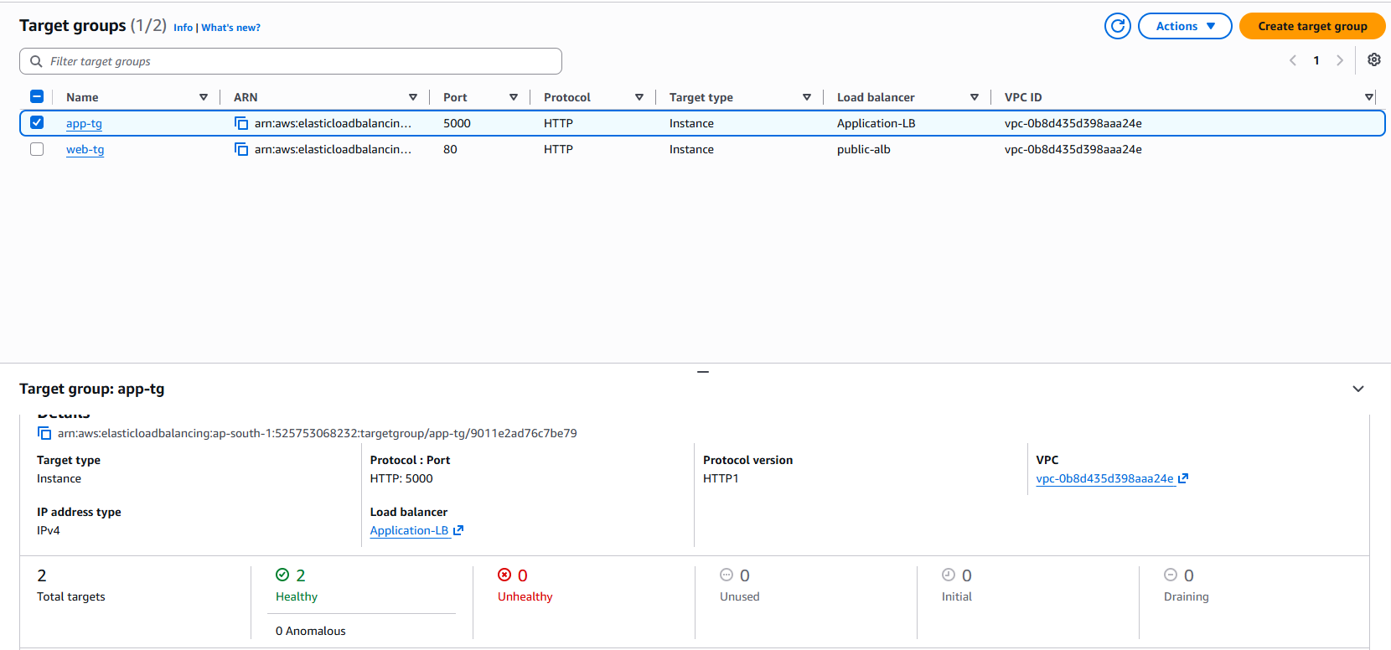

5. Verifying communication between the web tier and the application tier
Because the load balancer is internal, I tested it from a web server. I connected to Devops server through Session Manager and ran:
curl http://internal-Application-LB-1582852053.ap-south-1.elb.amazonaws.com/
The response was {"status":"Flask is running"}. This confirms that the web tier can reach the Flask application servers through the internal load balancer.
Screenshot 3: curl command and its output from the web server.
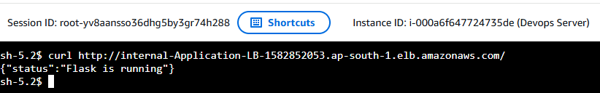

6. Result
The application tier now sits behind an internal load balancer. It distributes requests between the two Flask servers, checks their health, and is reachable only from the web tier. The DNS name of this load balancer is used in the Nginx reverse proxy configuration in Task 8.

Task 8: Nginx Reverse Proxy for API Routing

1. Purpose
The Feedback Form is served by Nginx on the web servers, but the data has to be processed by the Flask application in the private application tier. The browser sends its requests to the same address as the page, under the path /api/. I configured Nginx as a reverse proxy, so it serves the web page itself and forwards the /api/ requests to the internal load balancer, which passes them to the Flask servers. This way the application servers are never exposed to the internet.

2. Backing up and replacing the Nginx configuration
I connected to the web server through Session Manager and saved a copy of the default configuration: sudo /etc/nginx/nginx.conf. where the Nginx user is nginx.

3. Configuration details
The configuration has one server block listening on port 80 with two locations:
- location /api/ uses proxy_pass to forward requests to the DNS name of the internal load balancer, http://internal-Application-LB-1582852053.ap-south-1.elb.amazonaws.com/. The trailing / removes the /api prefix, so a browser request to /api/submit reaches Flask as /submit, which is the route defined in app.py. The Host and X-Real-IP headers are passed on, so the application can see the original host and client address.

4. Testing and restarting Nginx
I tested the configuration with sudo nginx -t, which reported that the syntax is OK and the test is successful. I then restarted the service with sudo systemctl restart nginx, and the status shows active (running).
Screenshot 1: Output of sudo nginx -t and the Nginx service status (active running)
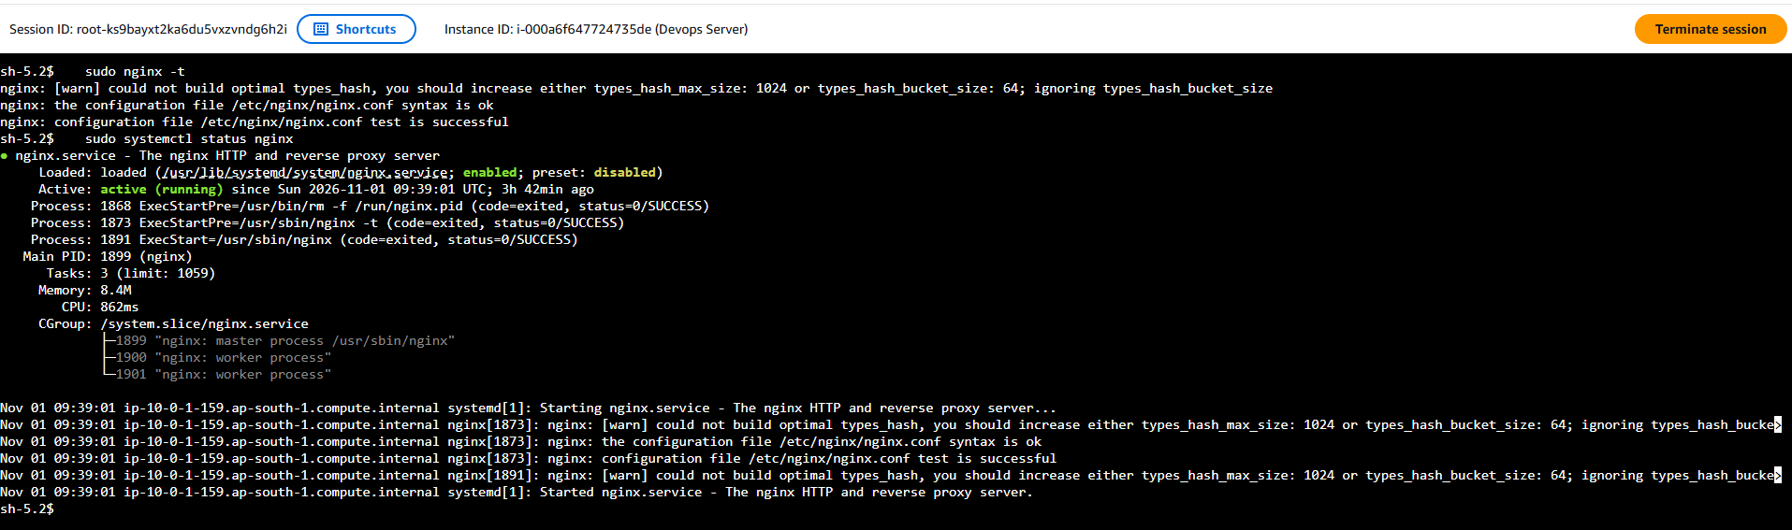

5. Verifying communication between the web tier and the application tier
From the web server I sent a request through the proxy:
curl http://localhost/api/
It returned {"status":"Flask is running"}, which came from a Flask server through Nginx and the internal load balancer. I also sent a test submission through the proxy:
curl -X POST http://localhost/api/submit -H "Content-Type: application/json" -d '{"name":"velu","email":"p@t.com","feedback":"Hello via Nginx"}'
The response was {"message":"Feedback submitted successfully!"}, and the record was stored in the Amazon RDS database.
Screenshot 2: curl output of the status request and of the test submission.
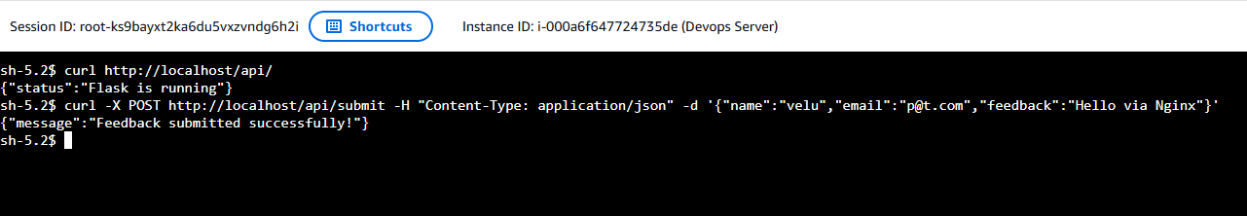

6. Second web server
I repeated the same configuration on the second web server named [server 2], because each server has its own Nginx configuration file. Both web servers now forward /api/ requests to the internal load balancer.
Screenshot 3: nginx.conf and the curl test on the second names as Server 2.
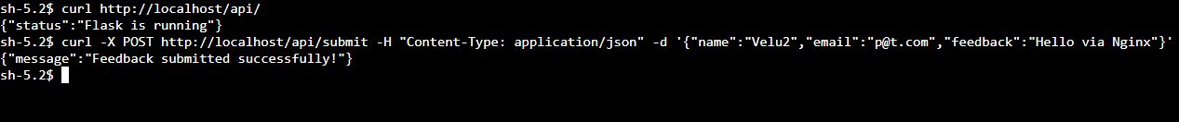

7. End-to-end verification through the public load balancer
I opened the Feedback Form using the public load balancer DNS name, http://public-alb-690072484.ap-south-1.elb.amazonaws.com, filled in the fields and clicked Submit. The page displayed the success message, and the record appeared in the feedback table in Amazon RDS. This confirms the full request path:
Browser → public ALB → Nginx (web tier) → internal ALB → Flask (application tier) → Amazon RDS.
Screenshot 4: SELECT * FROM feedback; output showing the stored record.
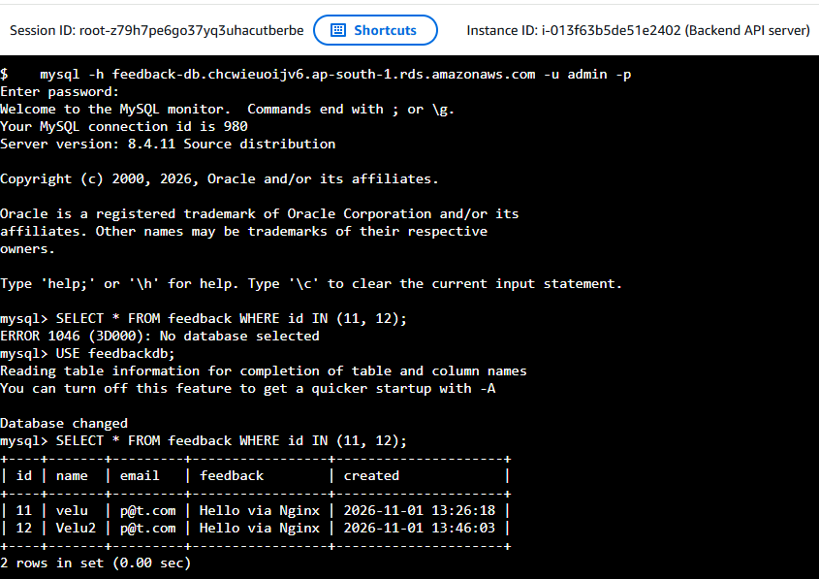

Task 9: Integrate the Flask Application with Amazon RDS

1. Configuring the database connection details
The Flask application connects to the database through a DB_CONFIG block at the top of app.py. I replaced the RDS-ENDPOINT placeholder with the endpoint of the RDS instance, feedback-db.chcwieuoijv6.ap-south-1.rds.amazonaws.com, and checked the other settings: the user admin, the master password, and the database name feedbackdb. I made the same change on both application servers, Backend API and Backend AMI, because each has its own copy of the file. The file was edited with a command, and I masked the password in the output shown below.
Screenshot 1: DB_CONFIG on Backend API & DB_CONFIG on Backend AMI.
- Backend API- Server
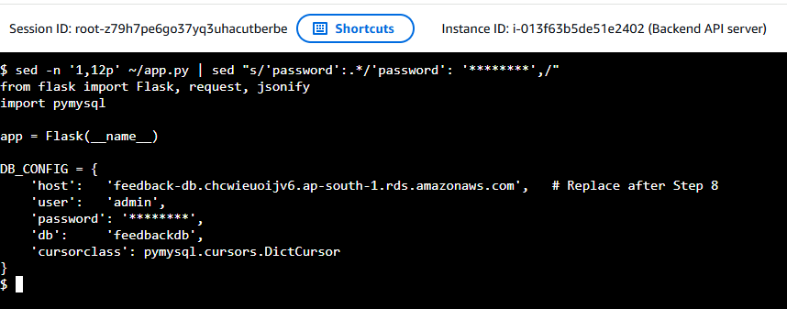
- Backend AMI- Server
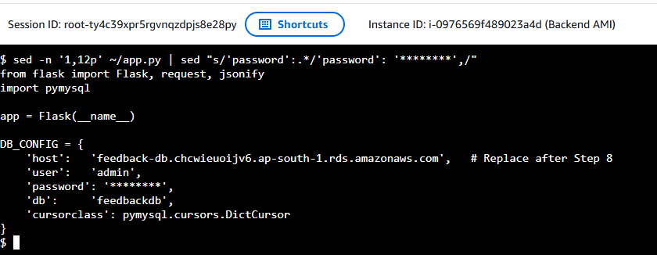

2. Restarting the application
The Flask application runs as a systemd service named flask-app. After changing the configuration, I restarted it with sudo systemctl restart flask-app, and the service status shows active (running).
Screenshot 2: Output of sudo systemctl status flask-app showing active.
- Backend API- Server
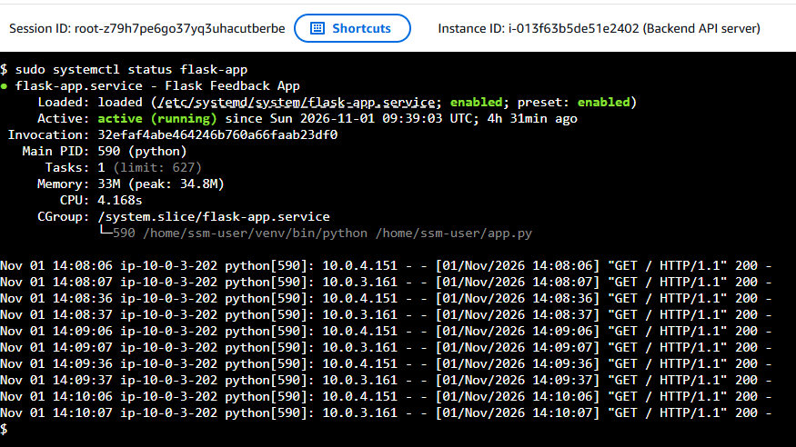
- Backend AMI- Server
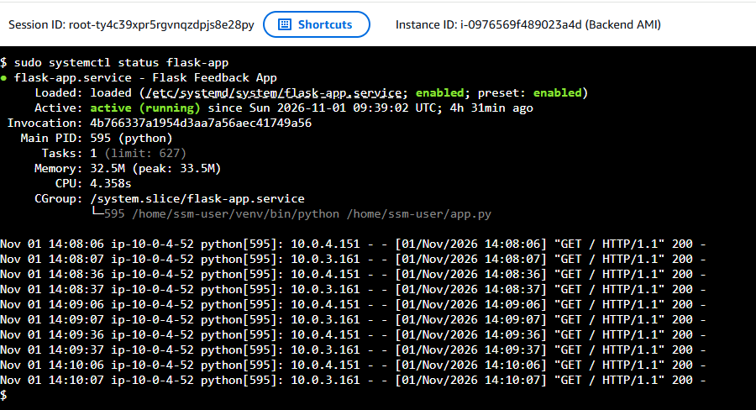

3. Verifying that the application connects to Amazon RDS
On each application server I sent a test submission directly to the Flask API:
curl -X POST http://localhost:5000/submit -H "Content-Type: application/json" -d '{"name":"Task9.1 Test","email":"test@example.com","feedback":"RDS connection check"}'
The API returned {"message":"Feedback submitted successfully!"}. The application sends this response only after the INSERT into the database has succeeded and been committed, so it confirms that Flask connects to RDS with the configured credentials. The database is in the private subnets and accepts connections only from the application security group app-sg.

4. Submitting sample feedback through the application
I opened the Feedback Form through the public load balancer, http://public-alb-690072484.ap-south-1.elb.amazonaws.com, entered sample test data [Name: Task 9 Demo, Email: demo@example.com, Feedback: Testing the full application] and clicked Submit. The page displayed the message “Feedback submitted successfully!”. The request traveled from the browser to the public ALB, then to Nginx, to the internal ALB, and to the Flask application.
Screenshot 3: Browser showing the submitted form and the success message, with the ALB DNS name in the address bar.
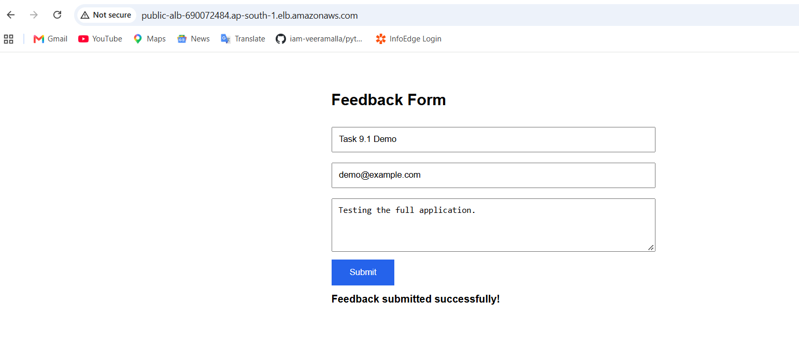

5. Confirming that the data is stored in the database
From an application server I connected to the database with the MySQL client:
mysql -h feedback-db.chcwieuoijv6.ap-south-1.rds.amazonaws.com -u admin -p
I selected the feedbackdb database and ran:
SELECT * FROM feedback ORDER BY id DESC LIMIT 5;
The newest rows include the record I submitted through the browser and the test records from the curl requests. Each row has an automatically assigned id and a created timestamp, which confirms that the data is persisted in Amazon RDS.
Screenshot 4: Output of the SELECT query showing the stored records
- Backend API- Server Output.
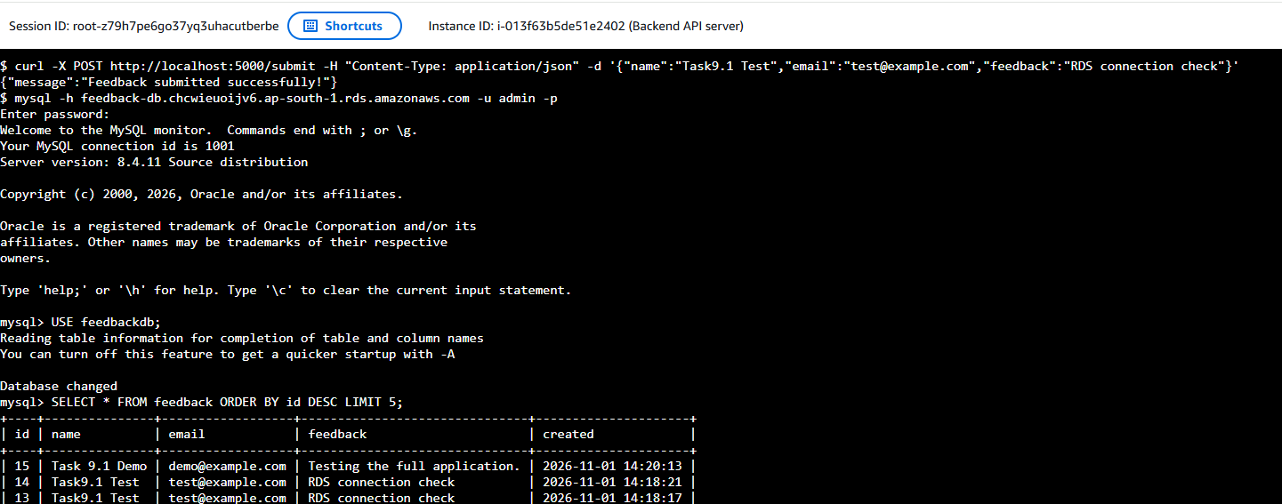
- Backend API- Server Output.
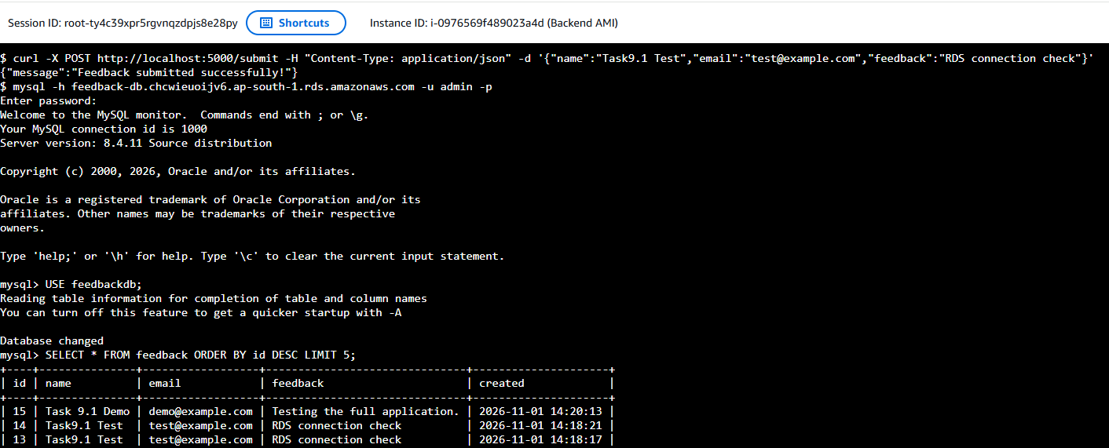

6. Result
The application tier is integrated with the database tier. The Flask servers store each feedback submission in the feedback table of the Amazon RDS MySQL database, and the data can be verified with SQL queries. The same configuration on both application servers means the data is saved correctly, whichever server the internal load balancer chooses.

Task 10: Validate the complete 3-tier Architecture

Overview
I validated the full architecture by sending a request through every layer, from the browser to the database, and by checking that the security groups allow only the required traffic. The request path is:
Browser → public ALB → Nginx (web tier) → internal ALB → Flask (application tier) → Amazon RDS MySQL.

1. Web application accessible through the public load balancer
I opened the DNS name of the public load balancer, http://public-alb-690072484.ap-south-1.elb.amazonaws.com, in a browser, and the Feedback Form loaded. The target group web-tg shows both web servers as Healthy, and the web servers are not reached directly, since their security group accepts traffic only from the load balancer.
Screenshot 1: web-tg targets tab with both web servers Healthy.
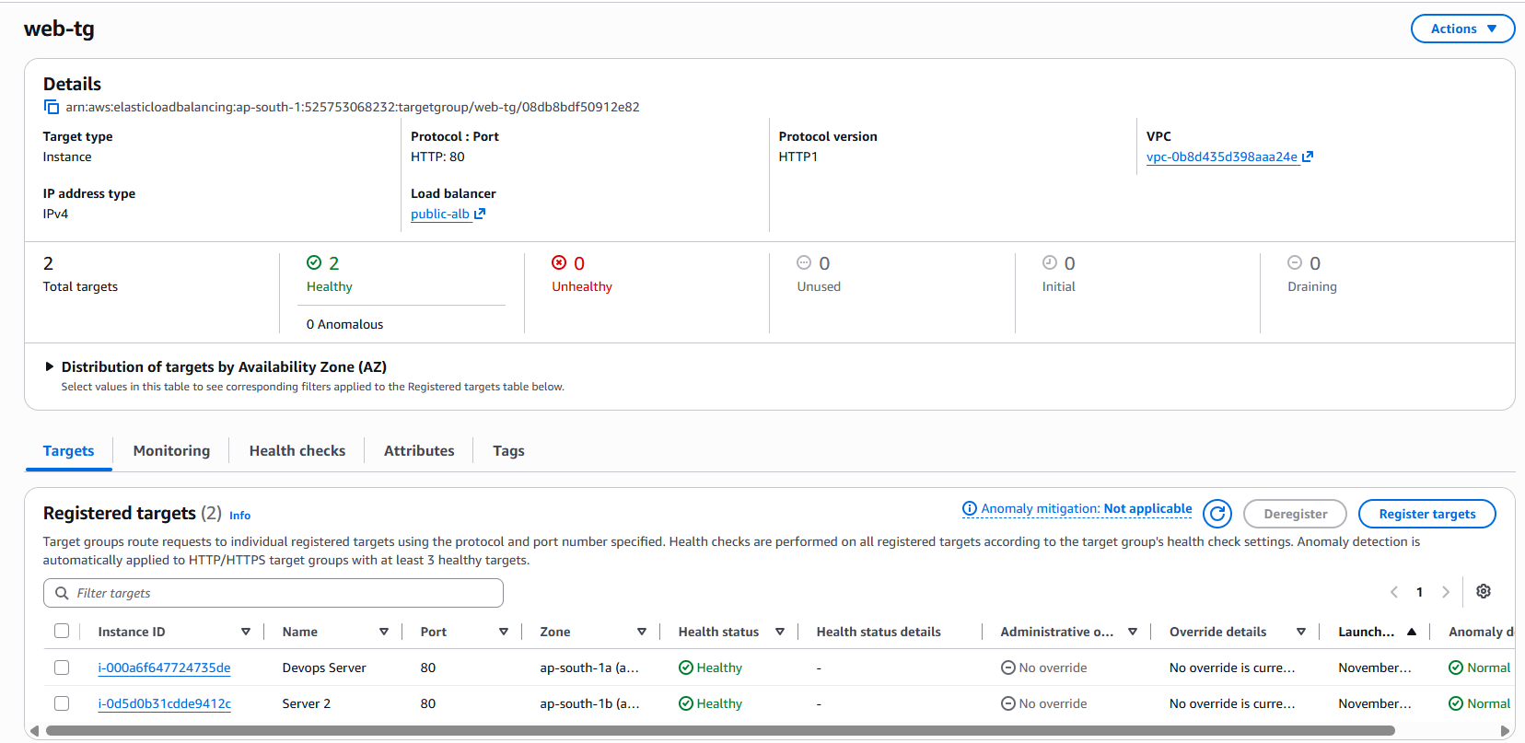

2. Feedback form accepts user input
I entered sample test data [Name: Testing Email:Testing@gmail.com, Feedback: Test Success] and clicked Submit. The page displayed the message “Feedback submitted successfully!”.
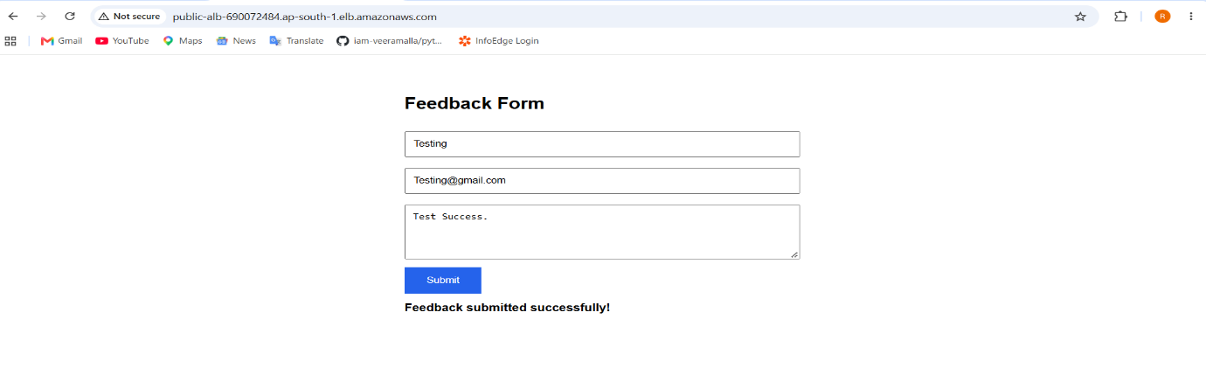

3. Nginx forwards API requests to the internal load balancer
On the web server named Devops server, the Nginx configuration forwards requests under /api/ to the internal load balancer with proxy_pass: grep proxy_pass /etc/nginx/nginx.conf. The output shows the internal load balancer DNS name. The Nginx access log shows the POST /api/submit request from the form with the status 200, which shows that the proxy received the browser’s request and passed it on successfully.
Screenshot 5: proxy_pass line in nginx.conf
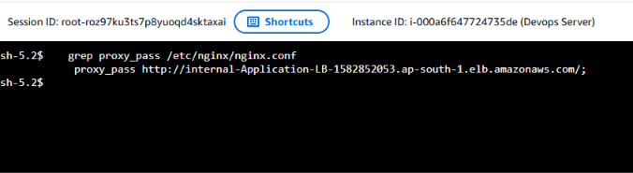
Screenshot 6: Nginx access log with the POST /api/submit entry
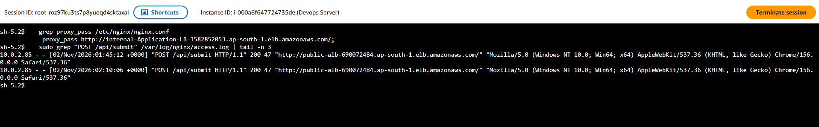

5. Feedback data stored in Amazon RDS MySQL and verified with SQL
From an application server I connected to the RDS instance with the MySQL client:
mysql -h feedback-db.chcwieuoijv6.ap-south-1.rds.amazonaws.com -u admin -p
I selected the feedbackdb database and ran:
SELECT * FROM feedback WHERE id = 17;
The newest row contains the data I entered in the form, with an automatically assigned id and a created timestamp. This confirms that the submission passed through all three tiers and was stored in the database.
Screenshot 9: MySQL session and the SELECT query output showing the stored record.
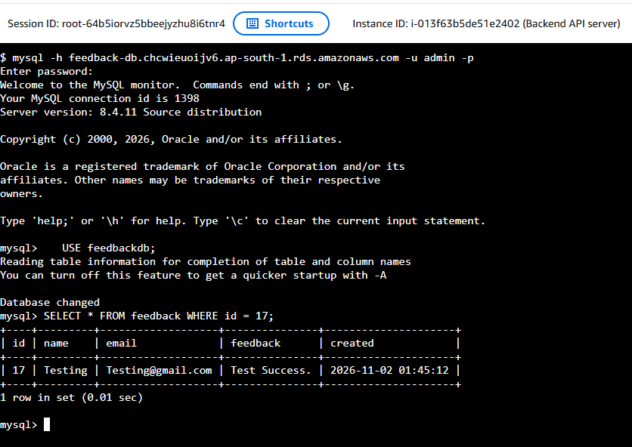

6. Security groups allow only the required traffic
I removed the temporary rules that I had used while building and testing. The final inbound rules are:
Security group | Protects | Allowed inbound traffic | Source
public-alb-sg | Public load balancer | HTTP, TCP 80 | Internet (0.0.0.0/0)
launch-wizard-2 | Web servers | HTTP, TCP 80 | public-alb-sg
internal-alb-sg | Internal load balancer | HTTP, TCP 80 | launch-wizard-2
app-sg | Application servers | Custom TCP 5000 | internal-alb-sg
db-sg | Amazon RDS MySQL | MySQL/Aurora, TCP 3306 | app-sg

7. Conclusion
The test confirms that the three-tier architecture works as designed. The web tier in the public subnets serves the page, the application tier in the private subnets processes the API requests, and the database tier in the isolated private subnets stores the data. Each tier is spread over two.

AWS Architecture Overview
This project hosts a feedback application on AWS using a three-tier architecture in the VPC Dev task 1 (10.0.0.0/16) in ap-south-1. The tiers are spread across two Availability Zones, so the application stays available if one zone fails.
- Web tier: Two Nginx servers in public subnets sit behind an internet-facing Application Load Balancer. They serve the Feedback Form and forward /api/ requests to the internal load balancer.
- Application tier: Two Flask servers in private subnets sit behind an internal Application Load Balancer. They process the requests on port 5000.
- Database tier: Amazon RDS MySQL in isolated private subnets stores the feedback. It has no internet route and no public access.
Security: each tier accepts traffic only from the tier in front of it: public-alb-sg → launch-wizard-2 → internal-alb-sg → app-sg → Database Tier-SG. The private servers reach the internet only through a NAT Gateway, and all servers are managed through Session Manager, so no SSH port is open.
Request flow: User → Internet Gateway → public ALB → Nginx → internal ALB → Flask → RDS MySQL.
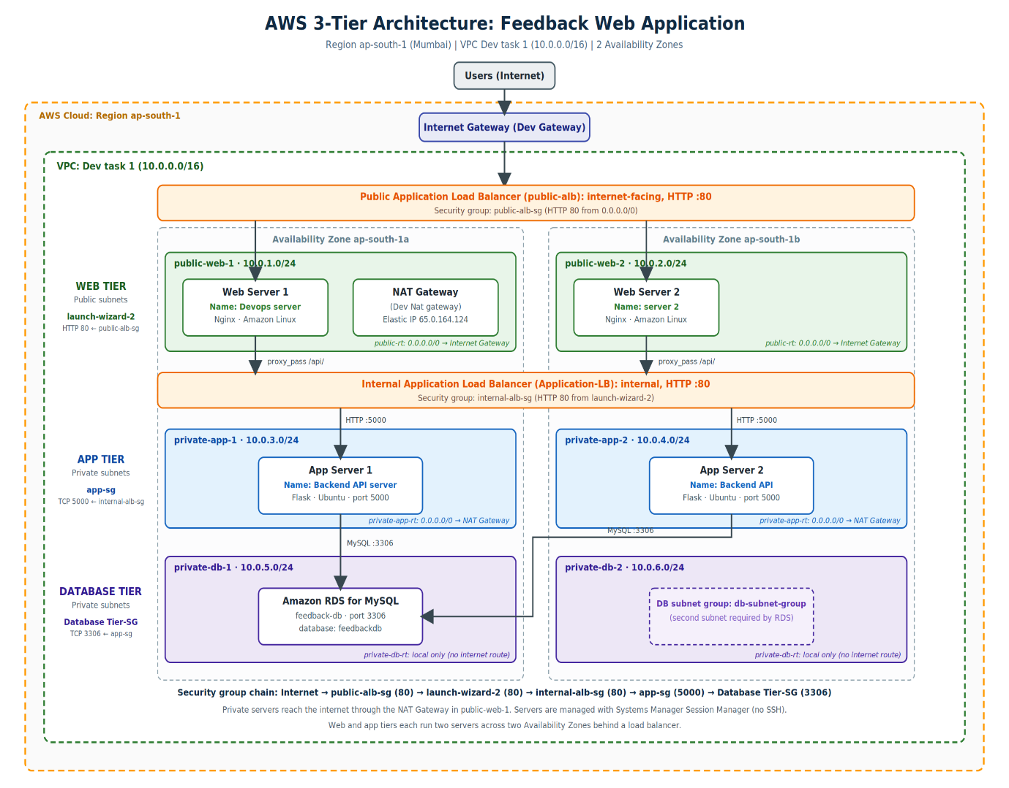

Additional Task: Configure Auto Scaling
Overview
To improve scalability and fault tolerance, I added Amazon EC2 Auto Scaling to the web tier and the application tier. Each tier now runs from a launch template in an Auto Scaling group that keeps the required number of healthy servers across two Availability Zones, replaces a server that fails, and adds servers when the load increases.
1. Creating AMIs from the configured servers
I created an Amazon Machine Image (AMI) from a fully configured web server and one from a fully configured application server, [web-ami-final and app-ami-final]. The web AMI contains Nginx with the reverse proxy configuration, and the application AMI contains the Flask service with the RDS connection settings, so every server launched from them works without any manual setup.
Screenshot 1: AMIs list showing both AMIs with status Available
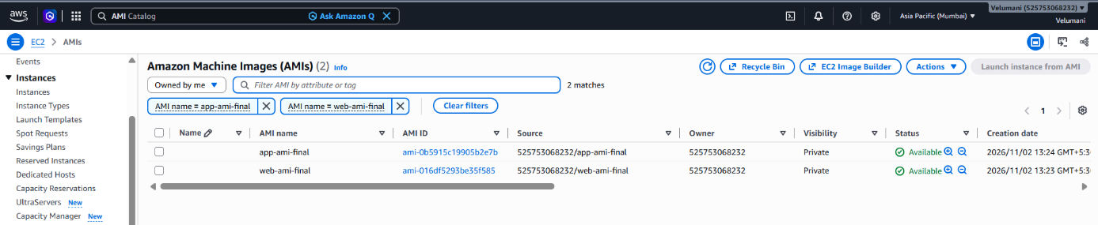

2. Creating the launch templates
I created two launch templates, web-lt and app-lt. Each uses its AMI, the instance type [t3.micro], no key pair, and the IAM role ssm-test-role for Session Manager access. The web template uses the security group launch-wizard-2, and the application template uses app-sg. The subnets are not fixed in the templates, because the Auto Scaling groups choose them. The templates also add the Name tag [web-asg-server and app-asg-server] to the instances they launch.

Screenshot 2: Launch template web-lt details & Launch template app-lt details.
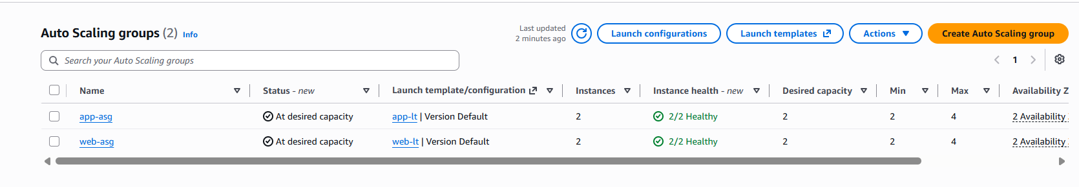

3. Web tier Auto Scaling group
I created the Auto Scaling group web-asg from web-lt in the VPC Dev task 1, using the public subnets public-web-1 and public-web-2, so the servers are spread across both Availability Zones. I attached the group to the existing target group web-tg and turned on Elastic Load Balancing health checks, so a server that fails the load balancer’s health check is replaced. The group has a desired capacity of 2, a minimum of 2 and a maximum of 4.
Screenshot 3: web-asg Details tab showing desired, minimum and maximum capacity
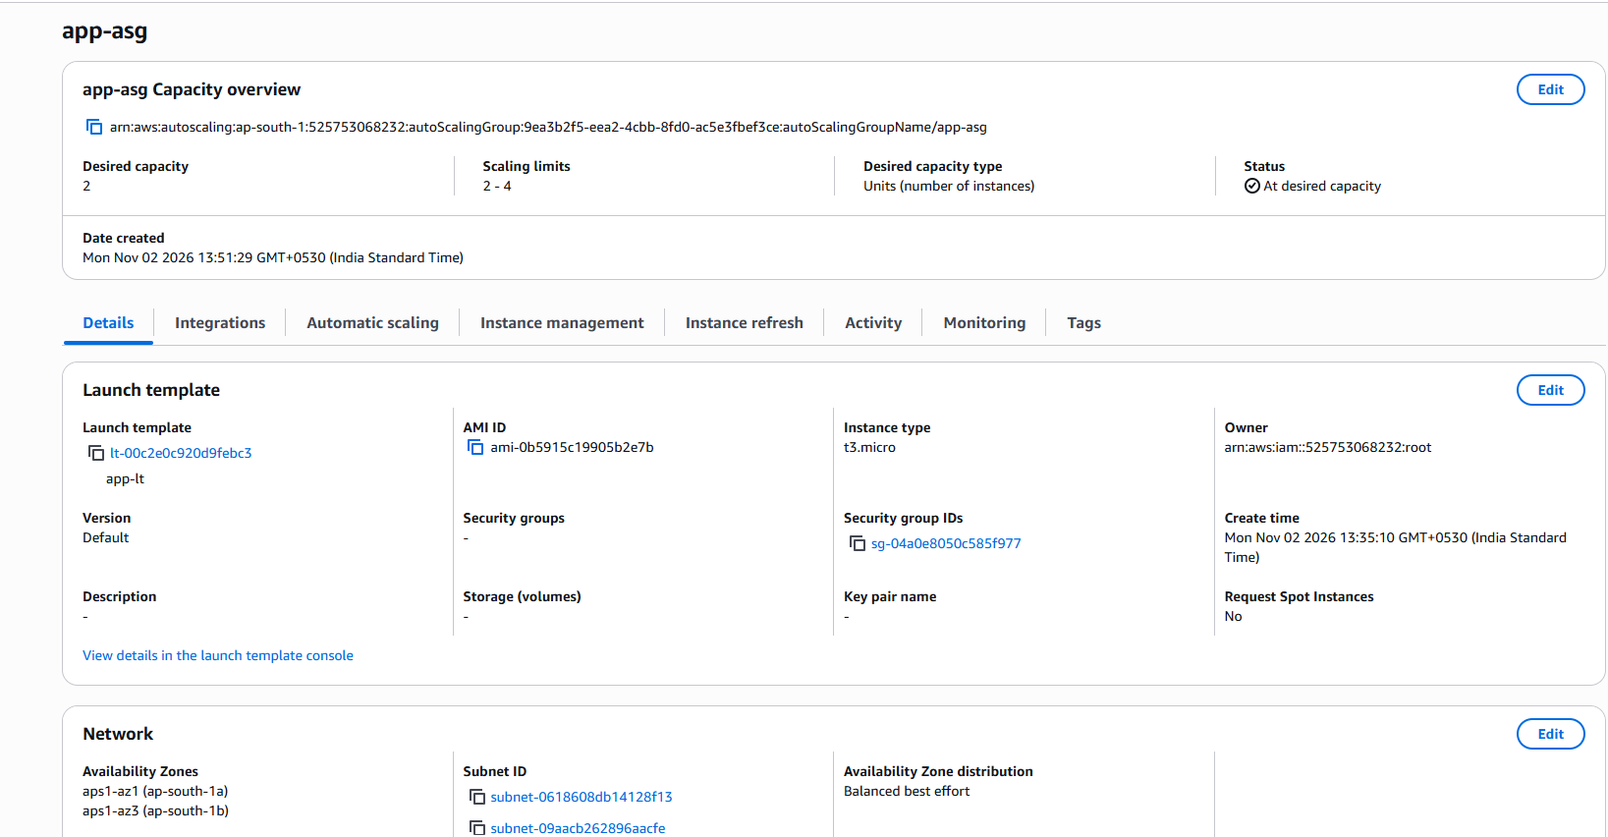

4. Application tier Auto Scaling group
I created the Auto Scaling group app-asg from app-lt in the private subnets private-app-1 and private-app-2. I attached it to the existing target group app-tg with Elastic Load Balancing health checks turned on, and used the same sizes: desired 2, minimum 2 and maximum 4. The servers have no public IP address.
Screenshot 4: app-asg Details tab showing desired, minimum and maximum capacity
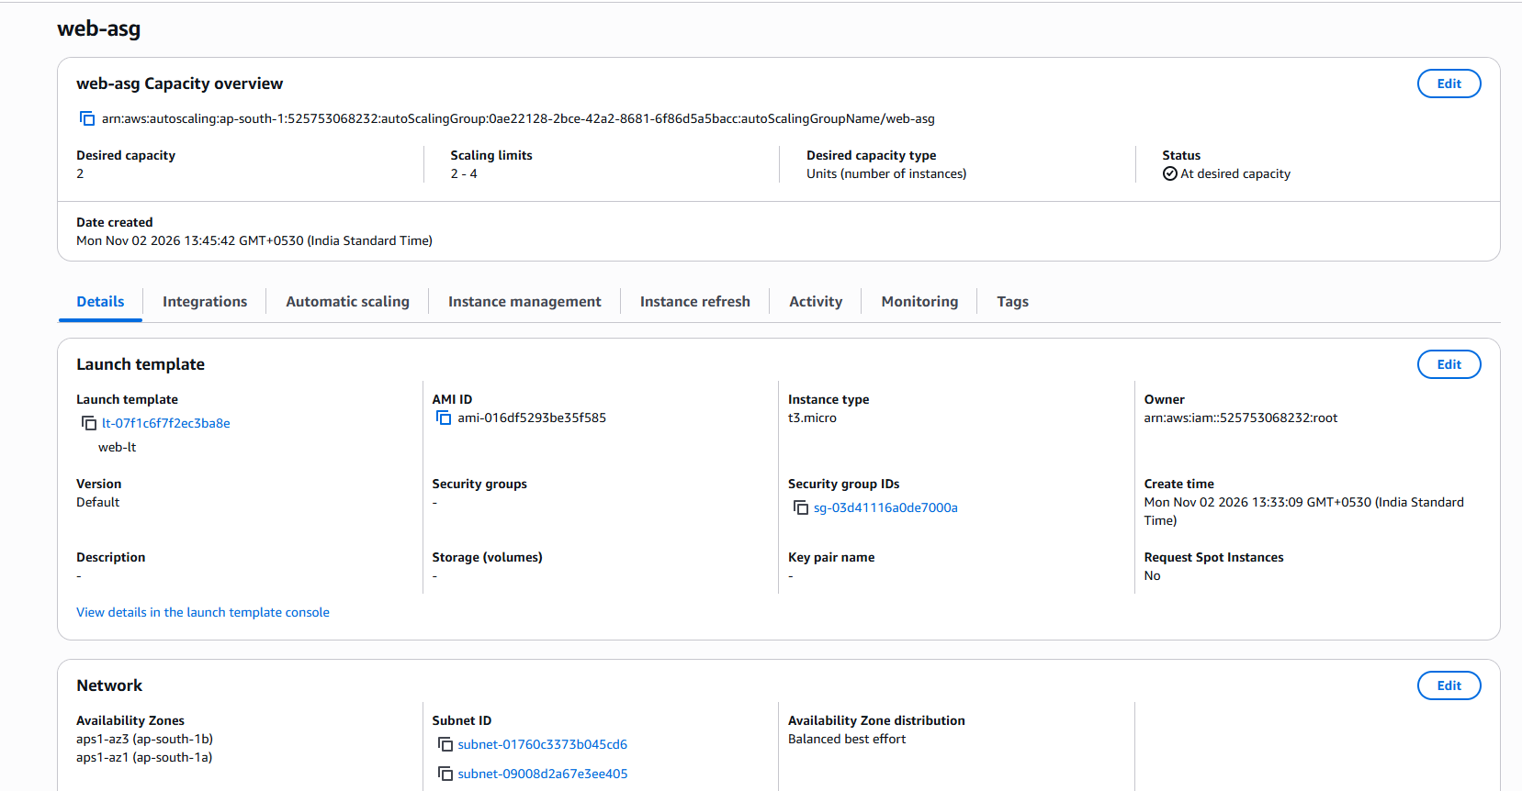
5. Scaling policy
For both groups I added a target tracking scaling policy on the metric Average CPU utilization with a target value of 50%. When the average CPU stays above 50%, the group launches more servers, up to the maximum of 4. When the load drops, it removes servers again, down to the minimum of 2.
6. Verifying the instances and target groups
Both groups launched their two instances, which show the status InService and are named [web-asg-server and app-asg-server]. The web servers are in the public subnets, and the application servers are in the private subnets with no public IPv4 address. In the target groups web-tg and app-tg, the new instances registered automatically and passed the health check, showing the status Healthy.
Screenshot 5: Targets tab of web-tg & app-sg with the new web servers Healthy.
- web-tg
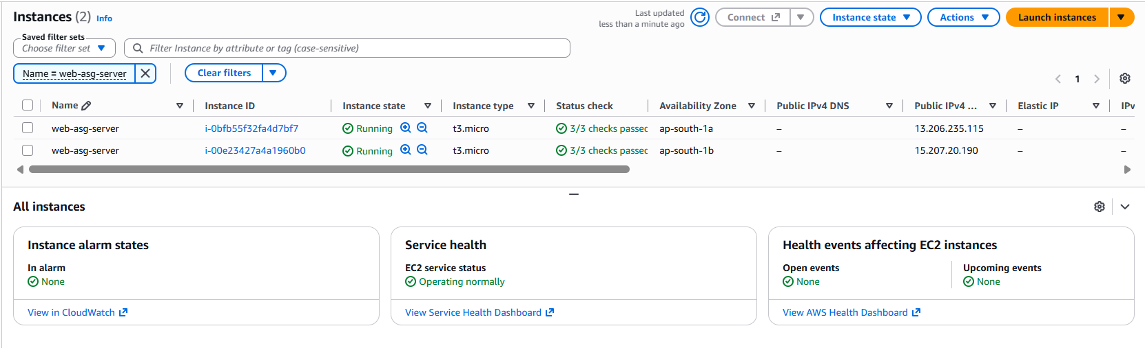
- app-sg
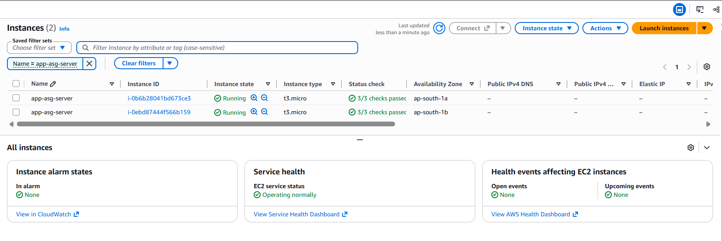

7. Testing the application
I opened the Feedback Form through the public load balancer DNS name, http://public-alb-690072484.ap-south-1.elb.amazonaws.com, entered test data and clicked Submit. The page displayed the message “Feedback submitted successfully!”, which confirms that the whole path works with the Auto Scaling servers in place.
Screenshot 6: Browser showing the success message with the ALB DNS name in the address bar.
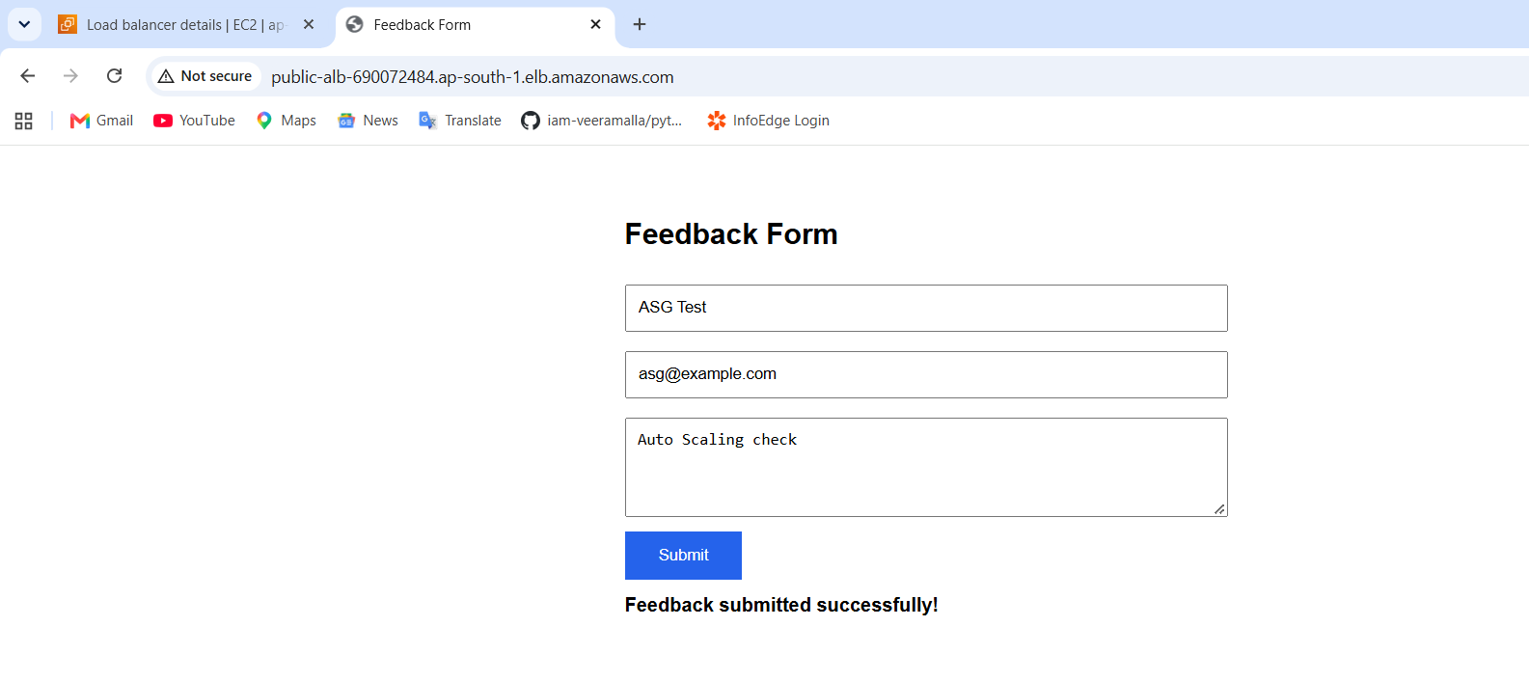
8. Fault tolerance test
To test self-healing, I manually terminated one instance of [web-asg]. The Activity history of the group shows that Auto Scaling detected the missing instance and launched a replacement automatically, returning the group to 2 instances. The application stayed available through the public load balancer during the replacement, because the other server kept serving requests.
Screenshot 7: Activity tab of the Auto Scaling group showing the termination and the replacement launch
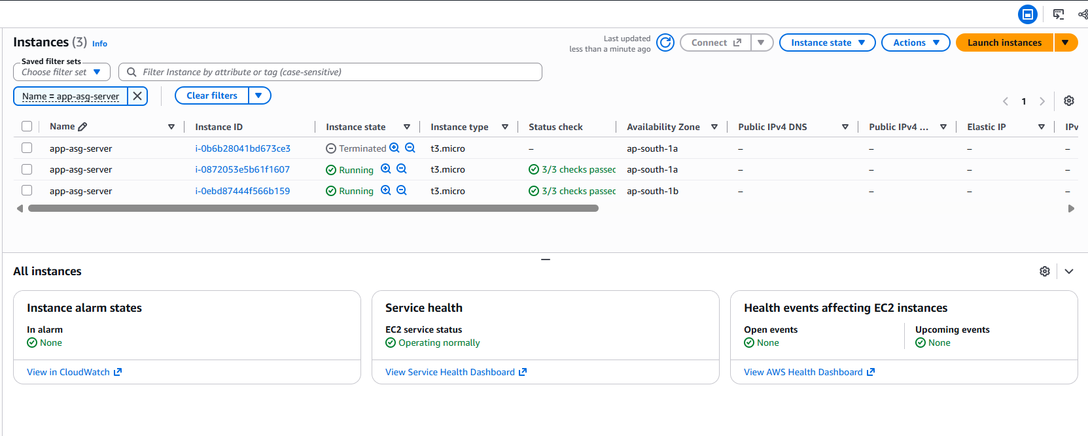
10. Result
With Auto Scaling, both the web tier and the application tier keep at least two healthy servers in two Availability Zones, replace failed servers automatically, and scale out when the CPU load increases. This improves the scalability and fault tolerance of the architecture without any change to the application.
Enhanced Architecture: Auto Scaling & High Availability
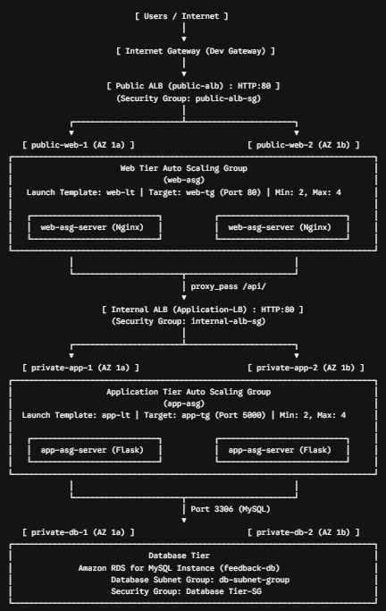
Important Project Links & Endpoints
- Public Web Application Entrypoint (ALB DNS):
http://public-alb-690072484.ap-south-1.elb.amazonaws.com
- Internal Load Balancer Private DNS:
http://internal-Application-LB-1582852053.ap-south-1.elb.amazonaws.com
- Amazon RDS MySQL Endpoint:
feedback-db.chcwieuoijv6.ap-south-1.rds.amazonaws.com:3306

